**Day 9**

**Java Exception, Assertions, List**

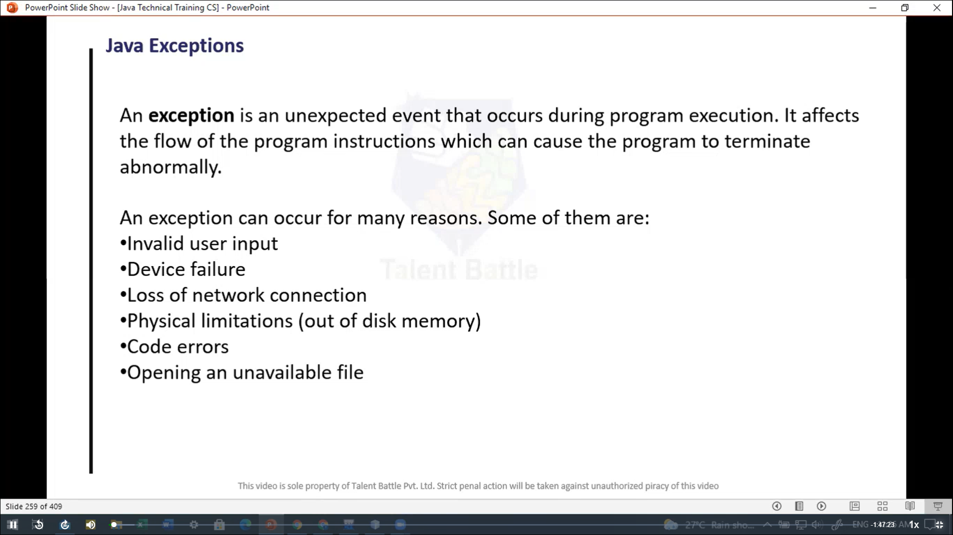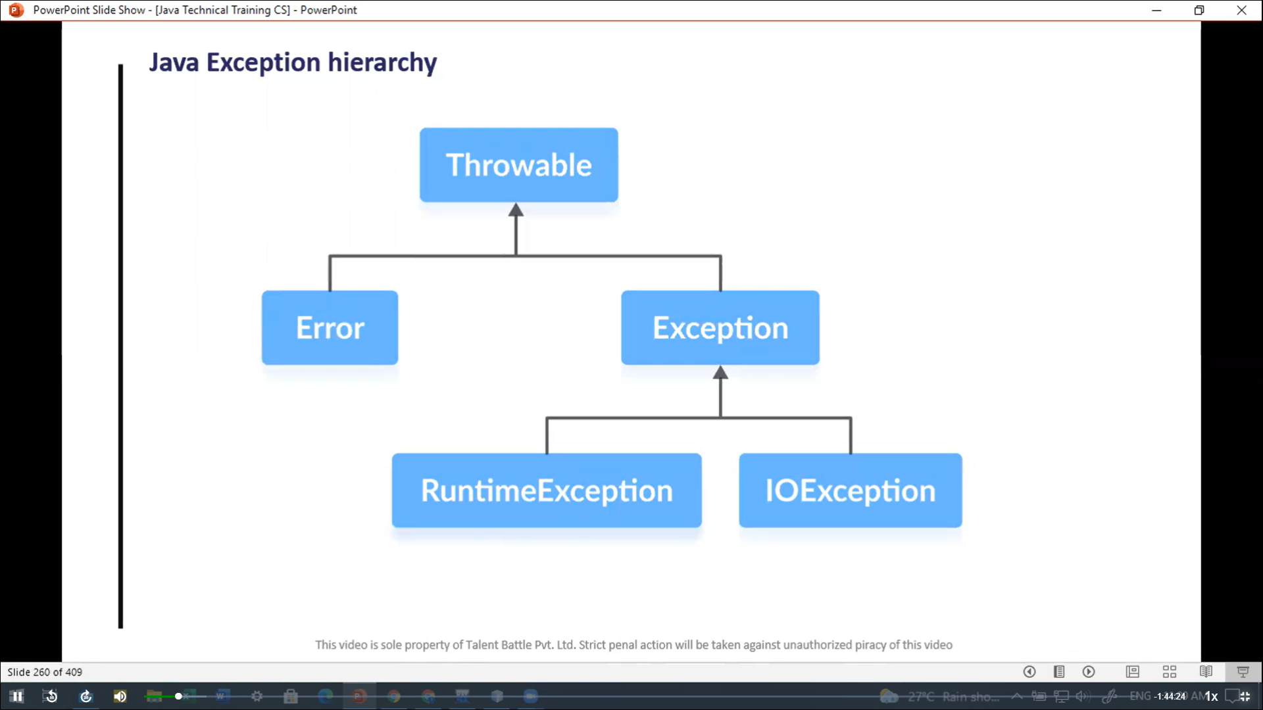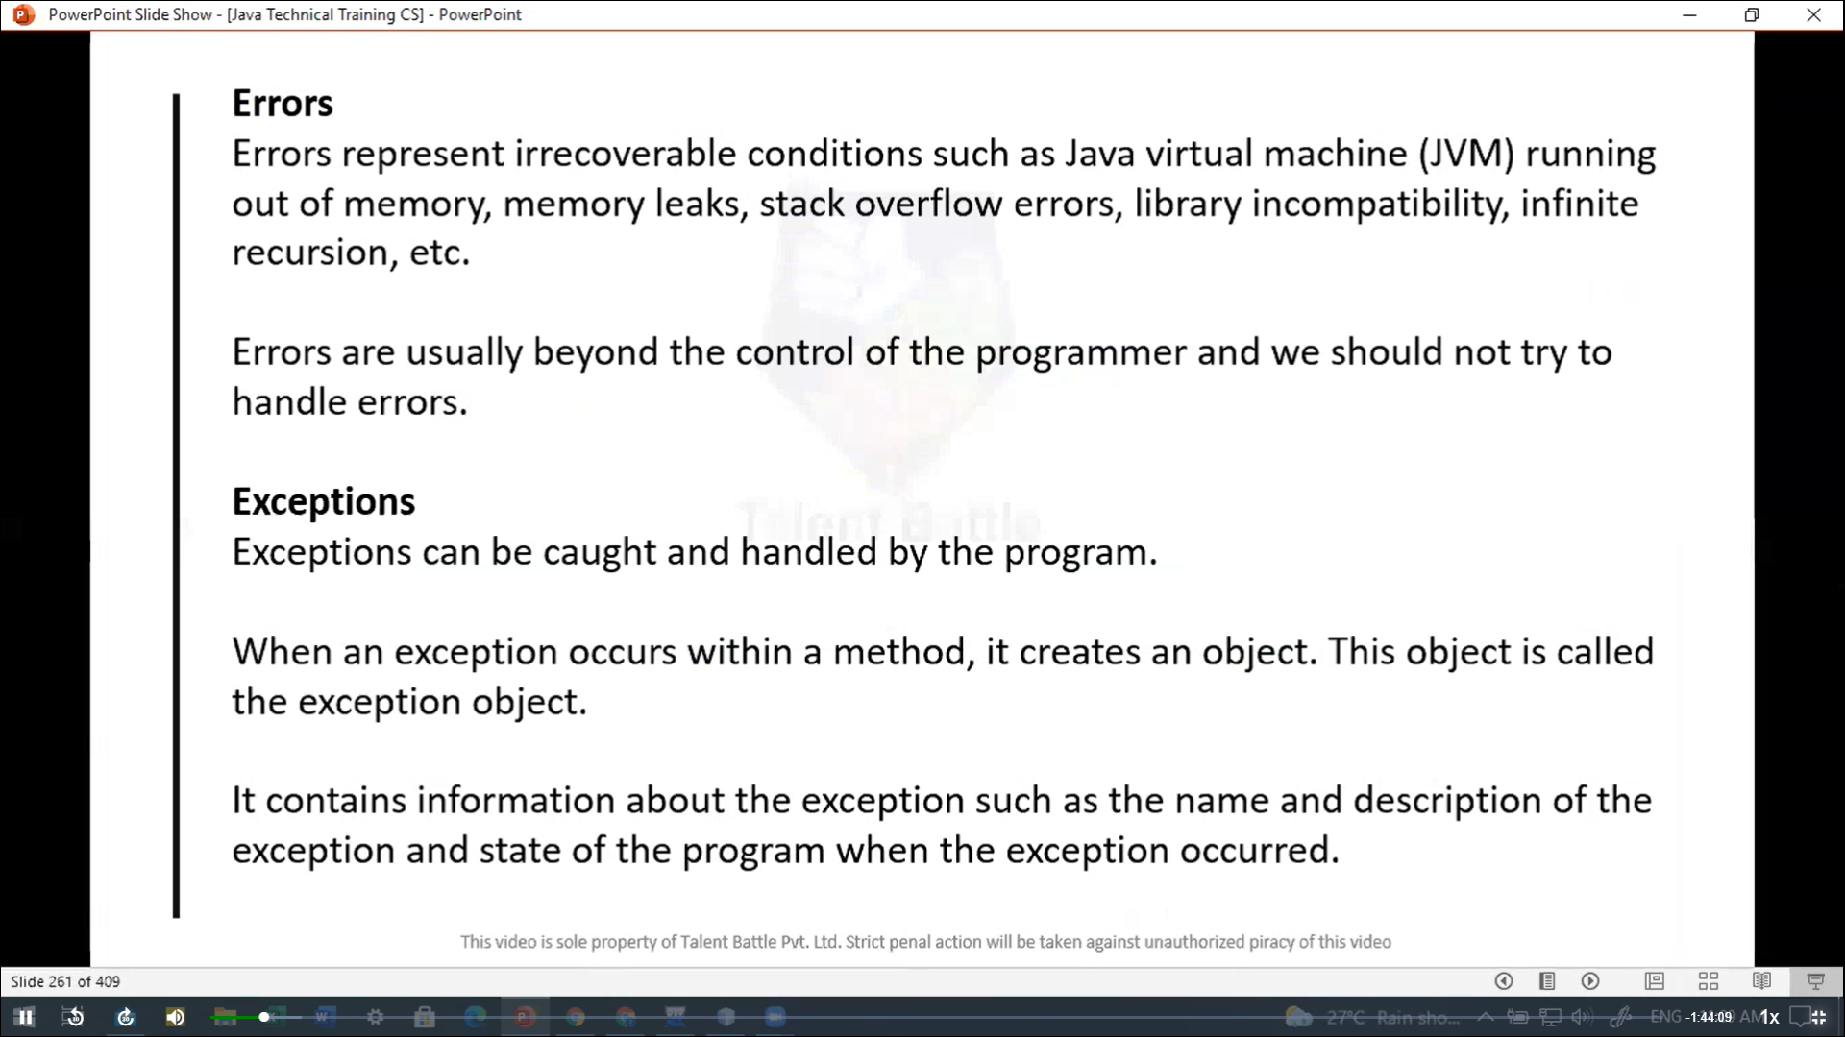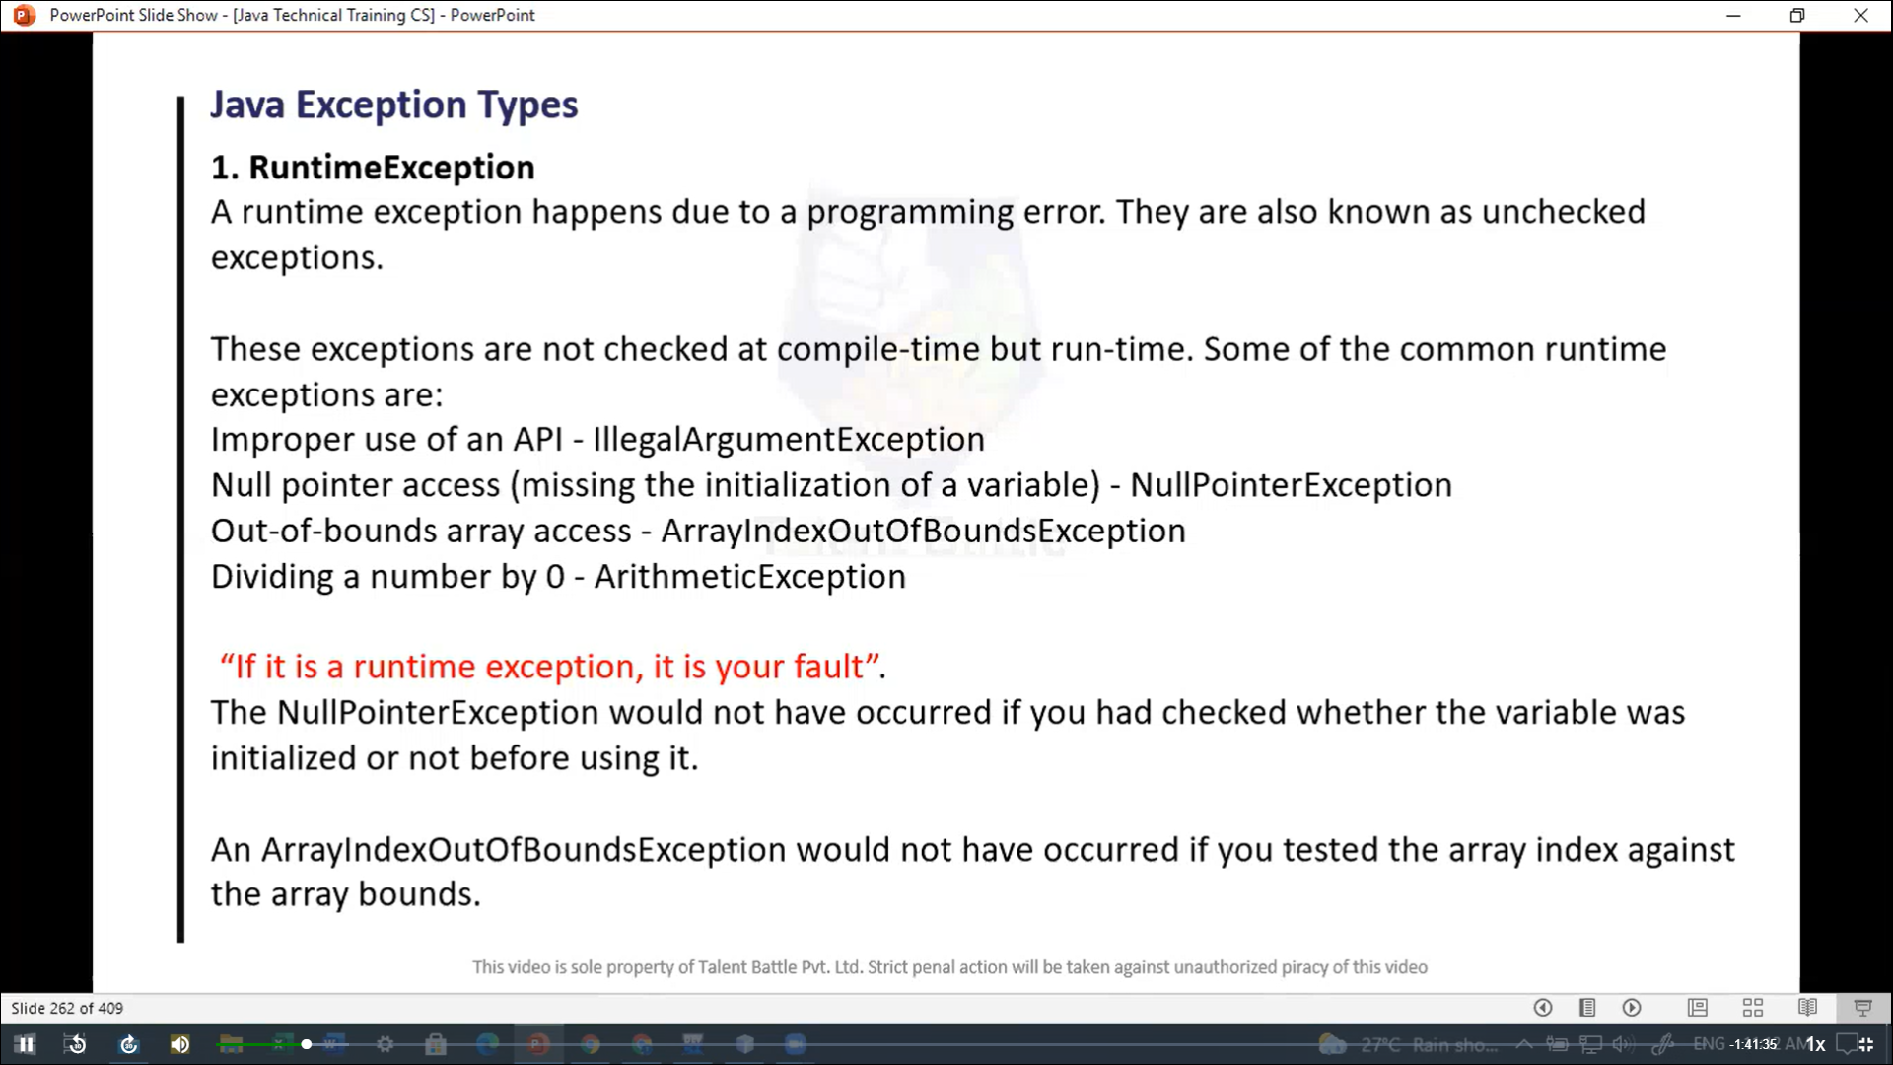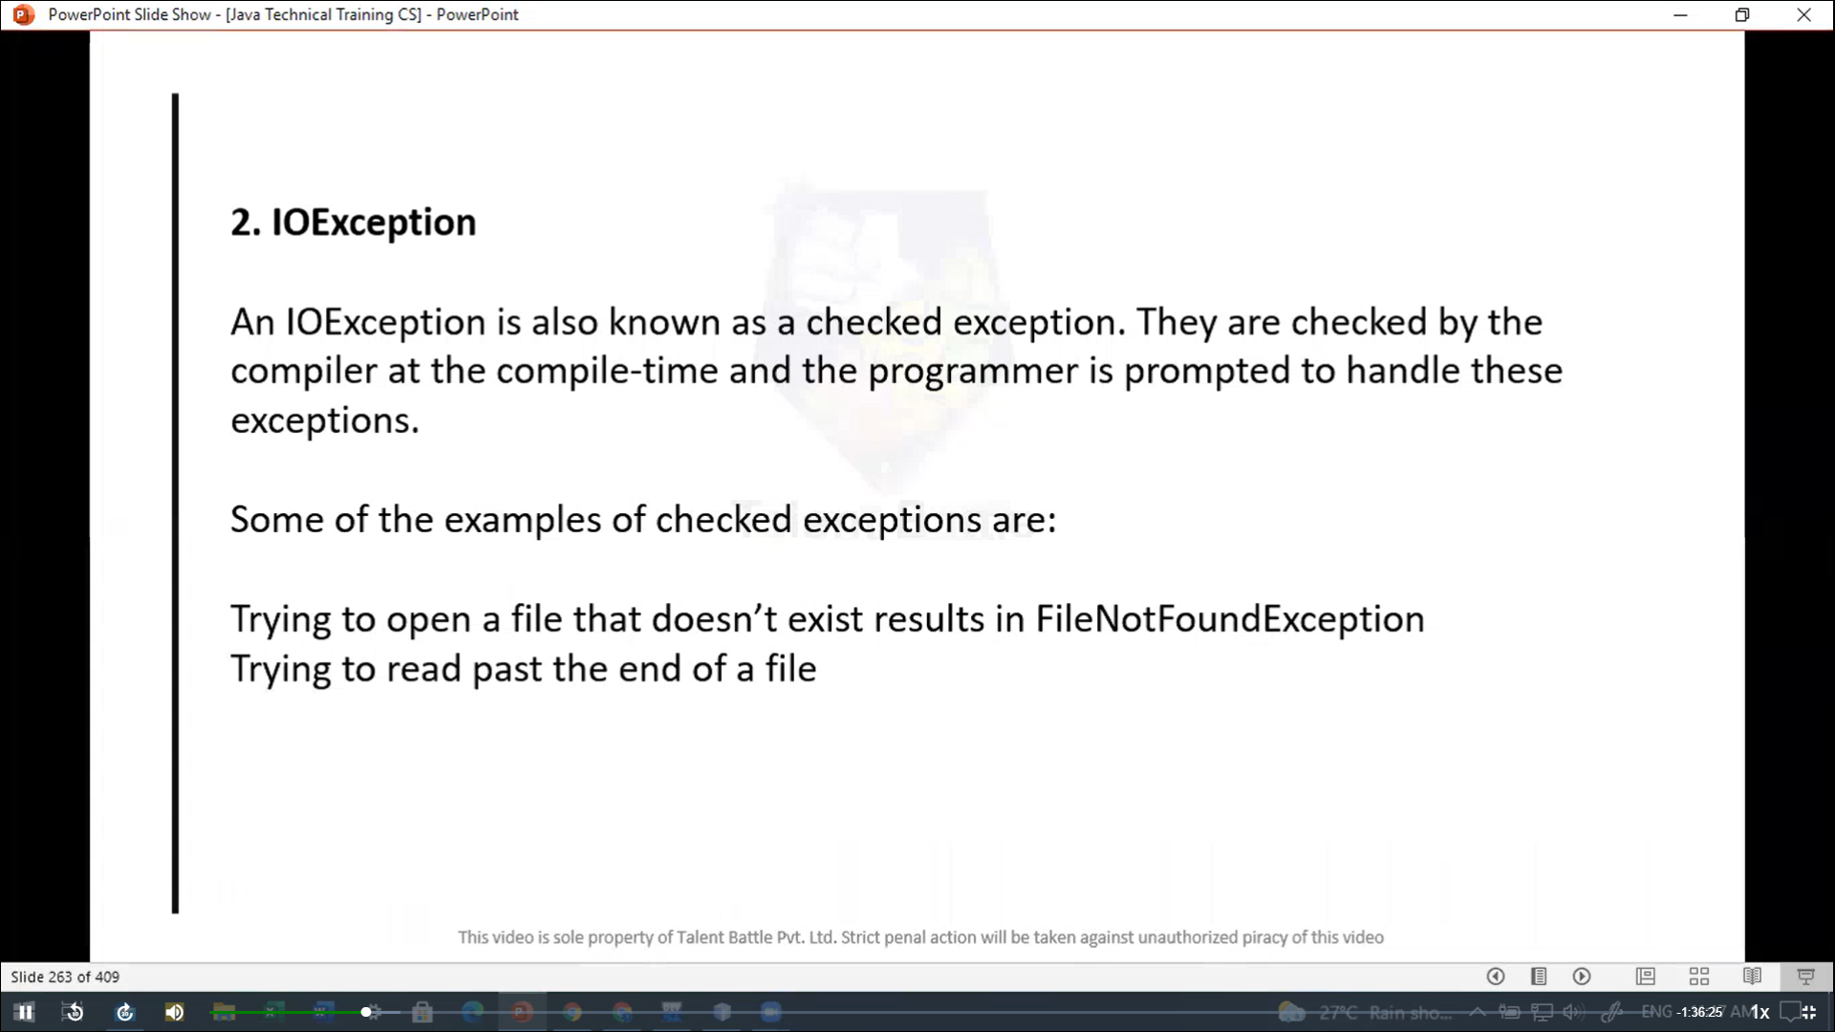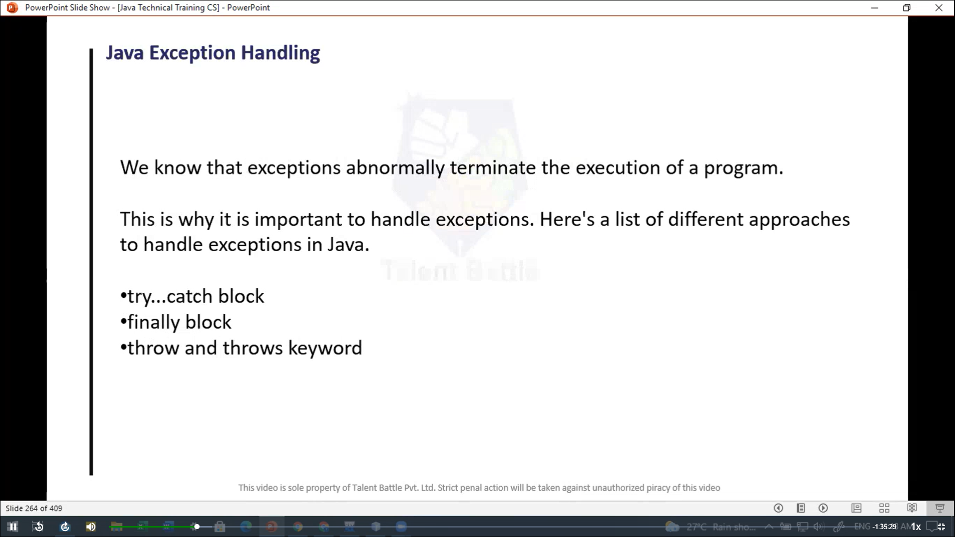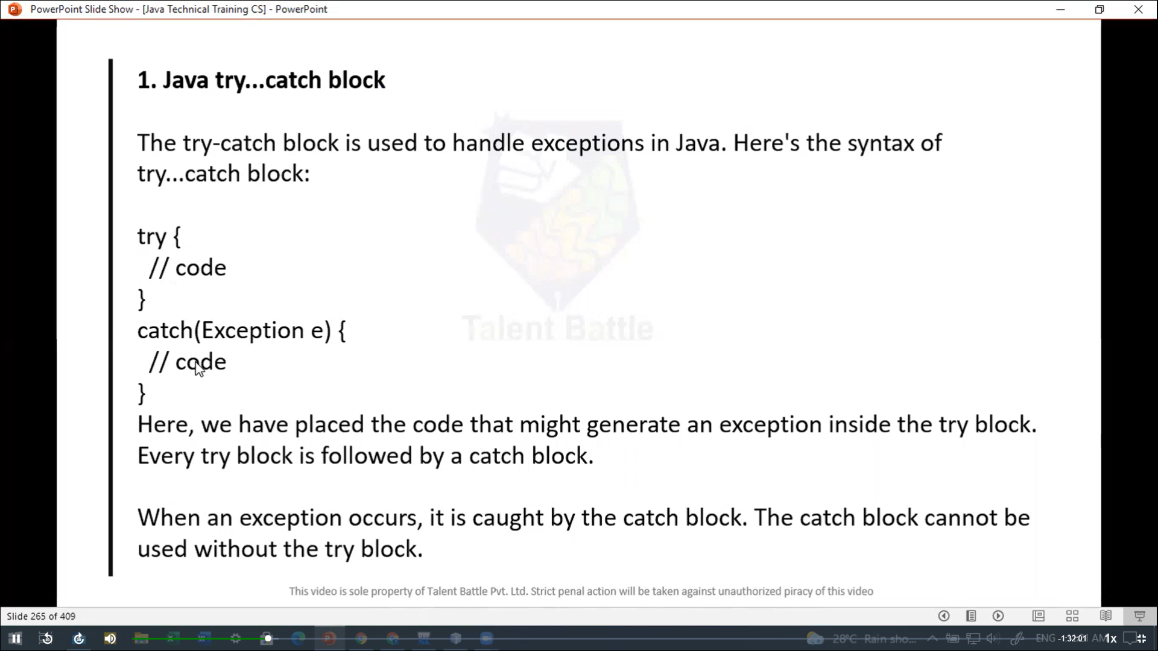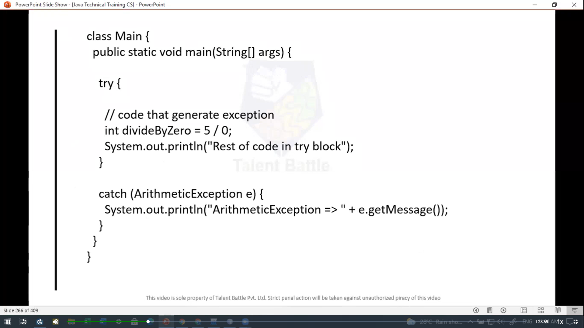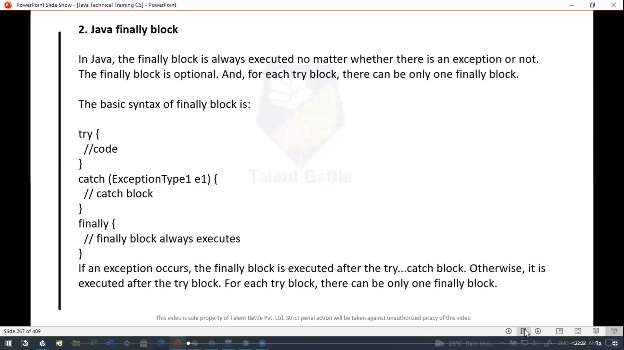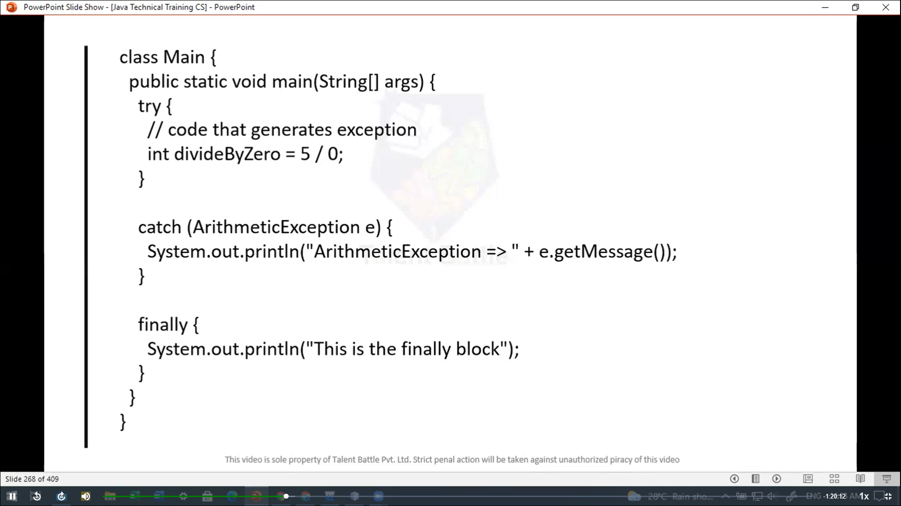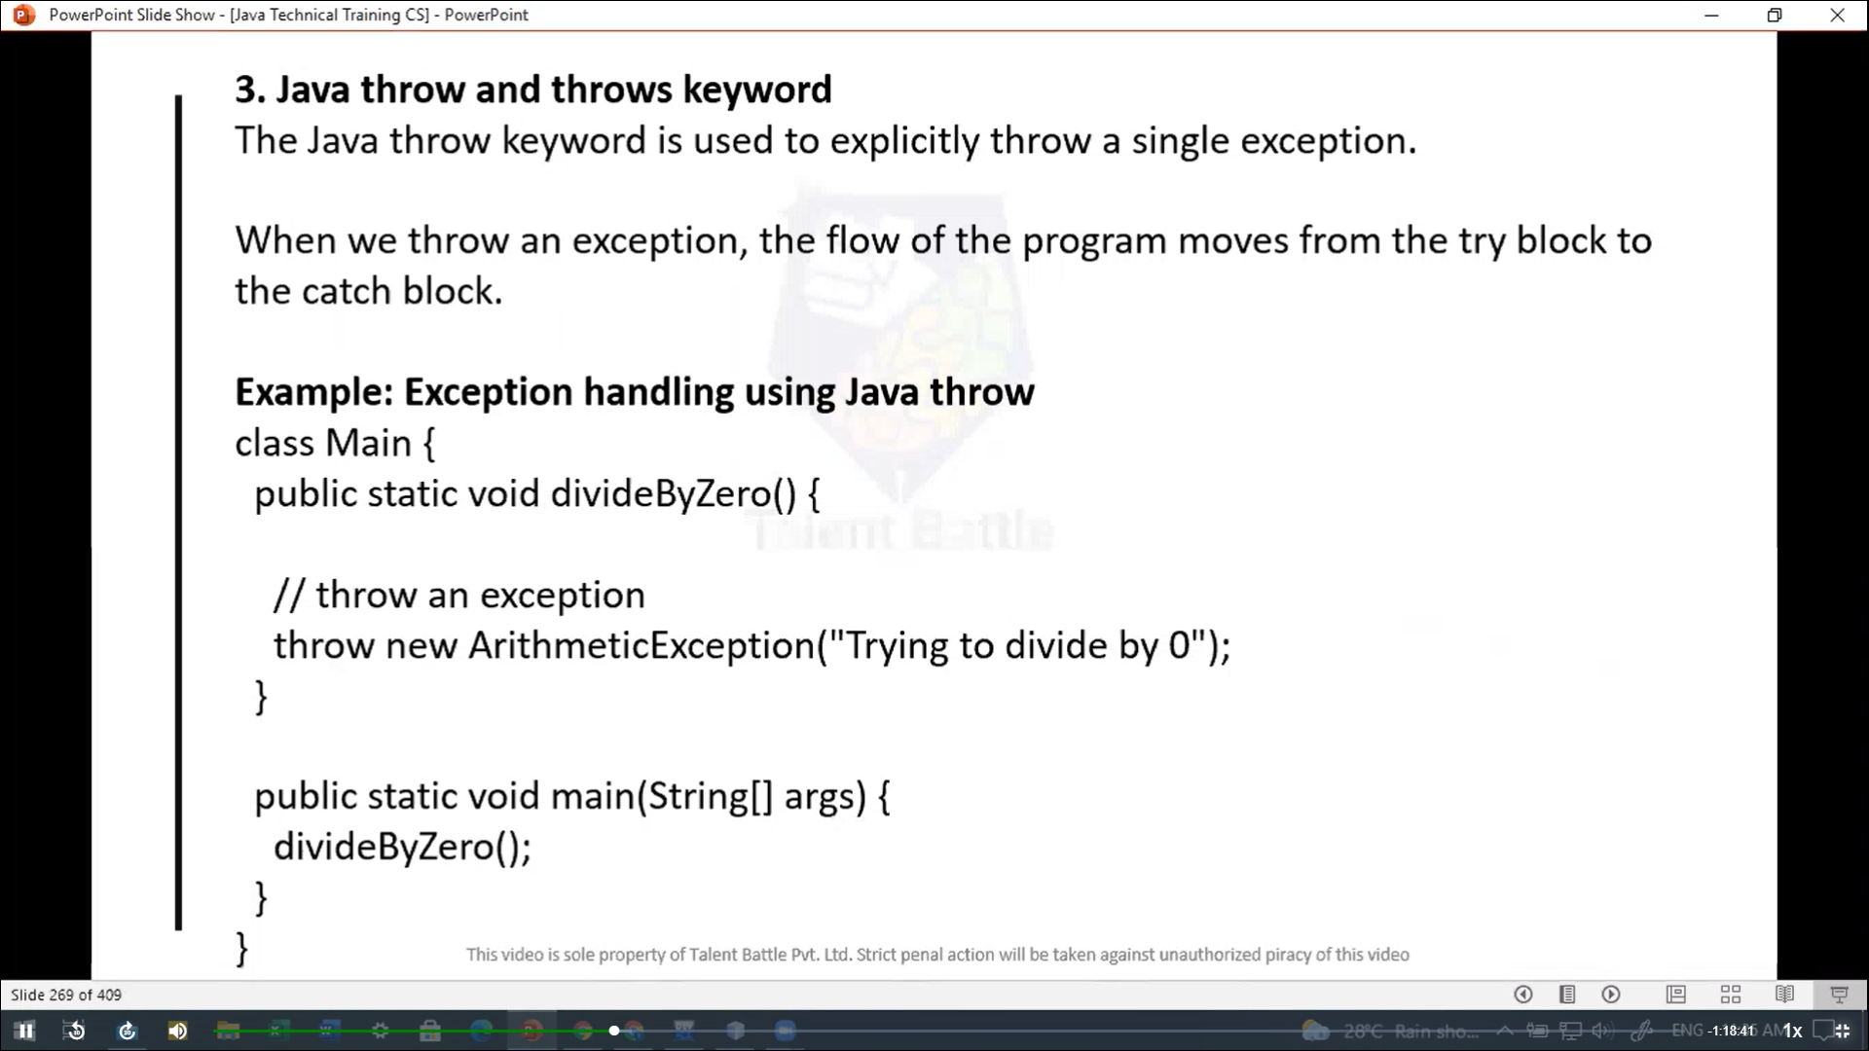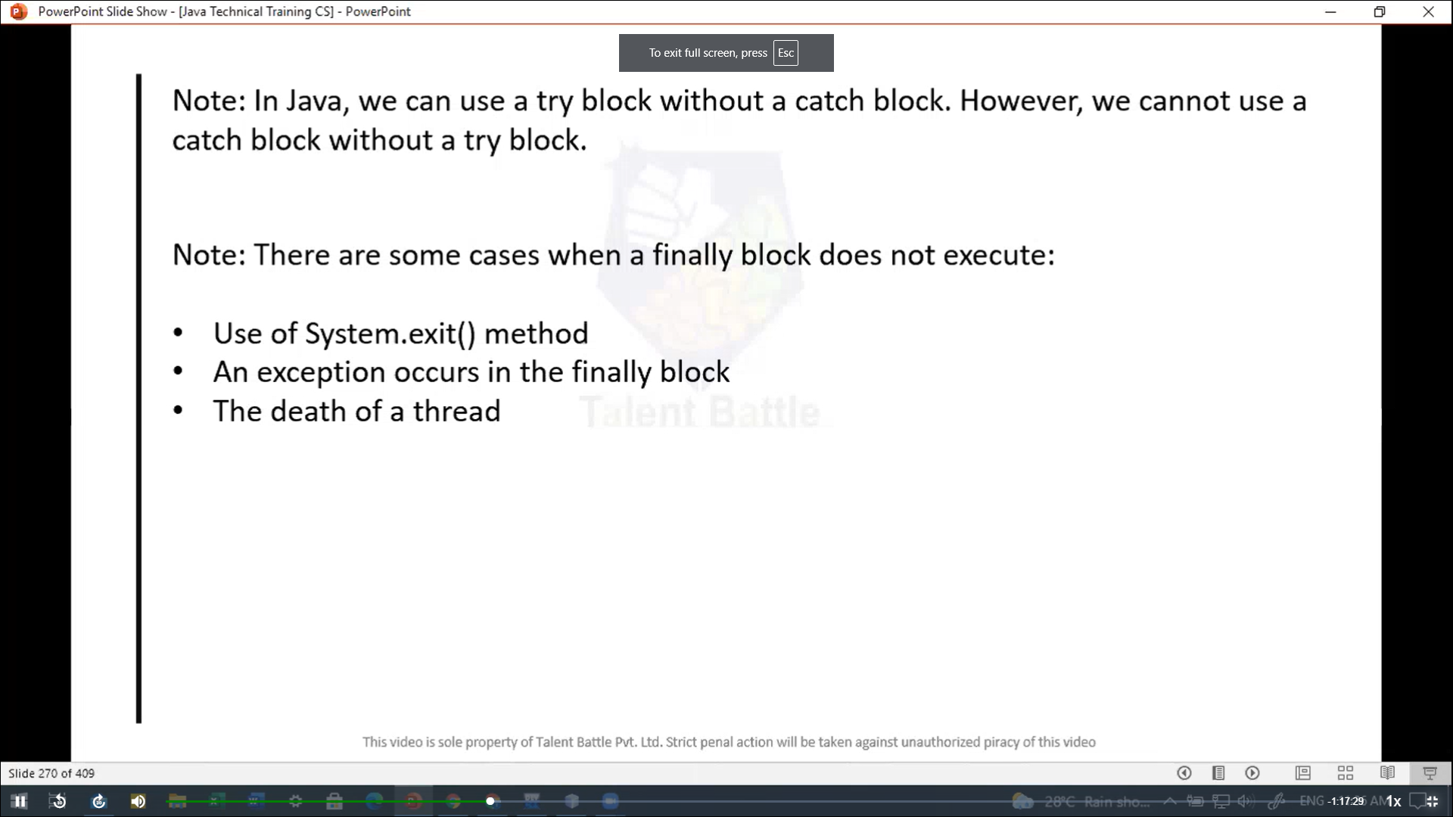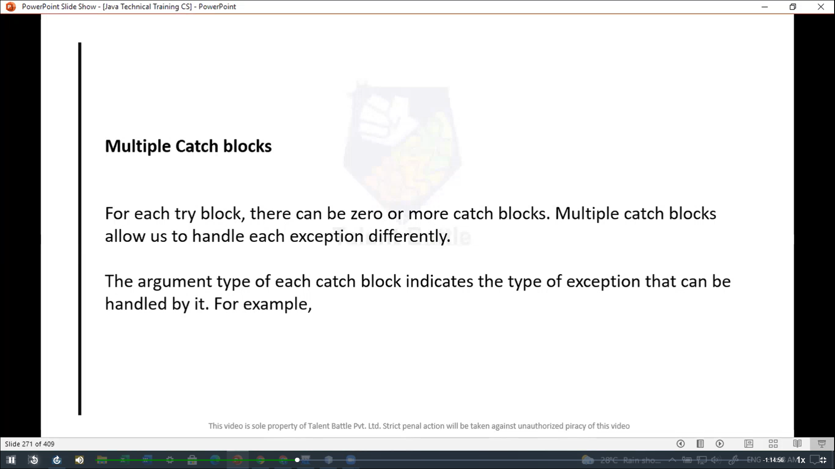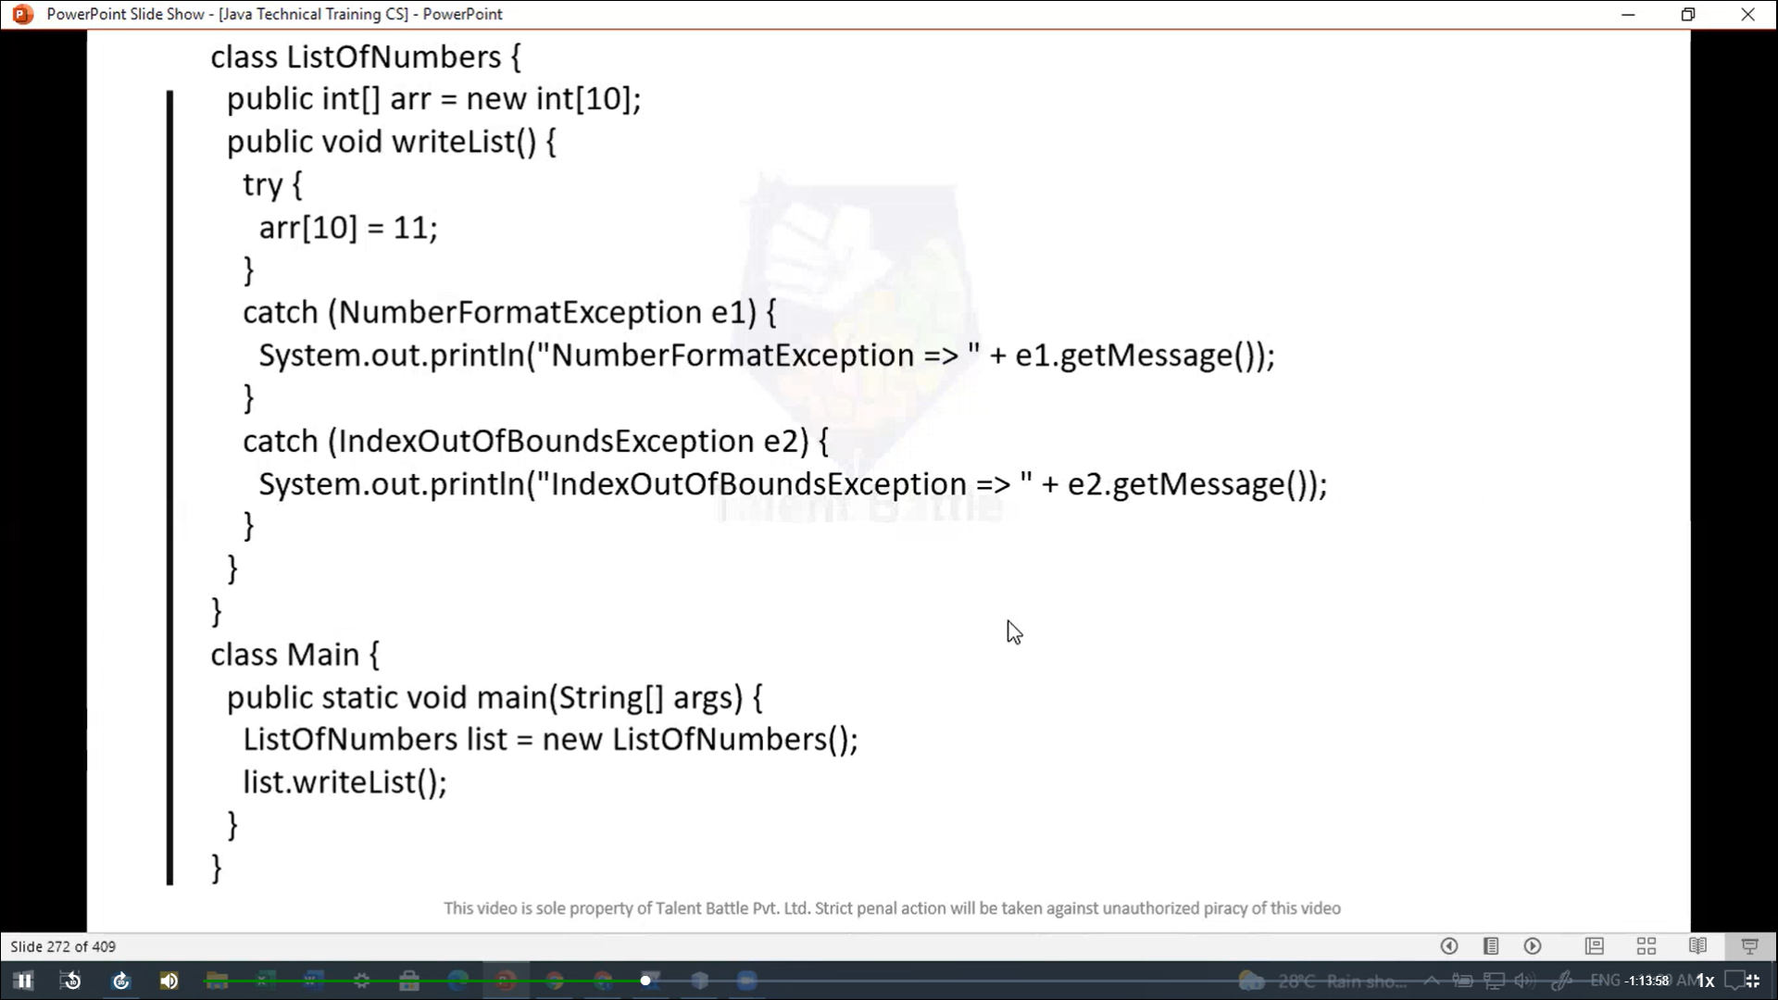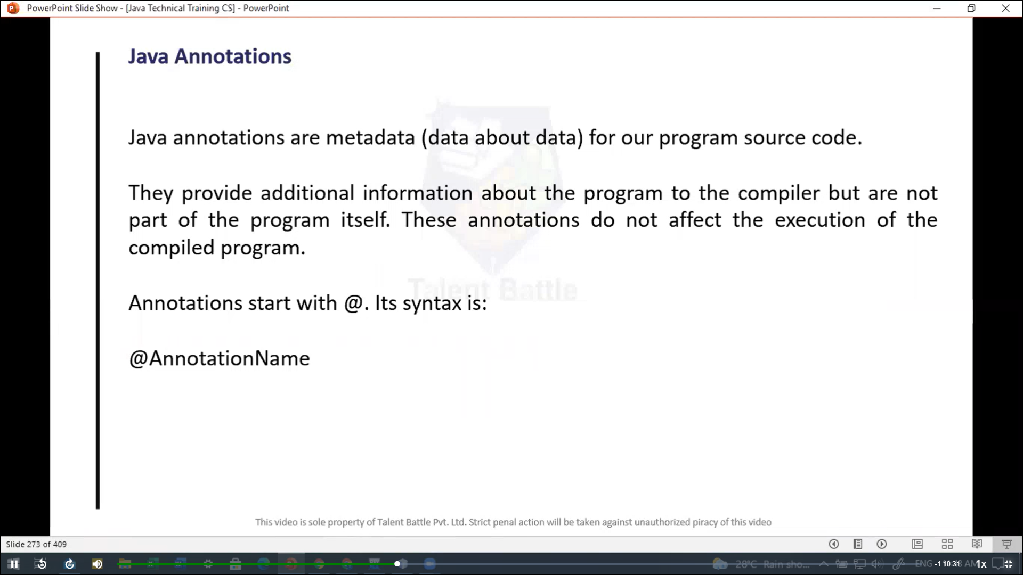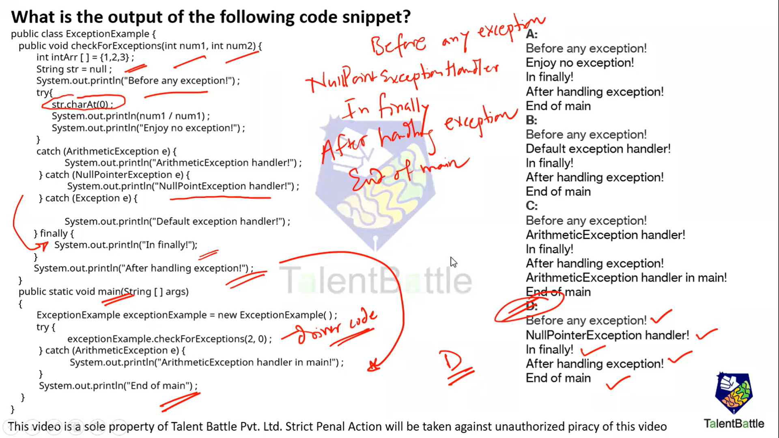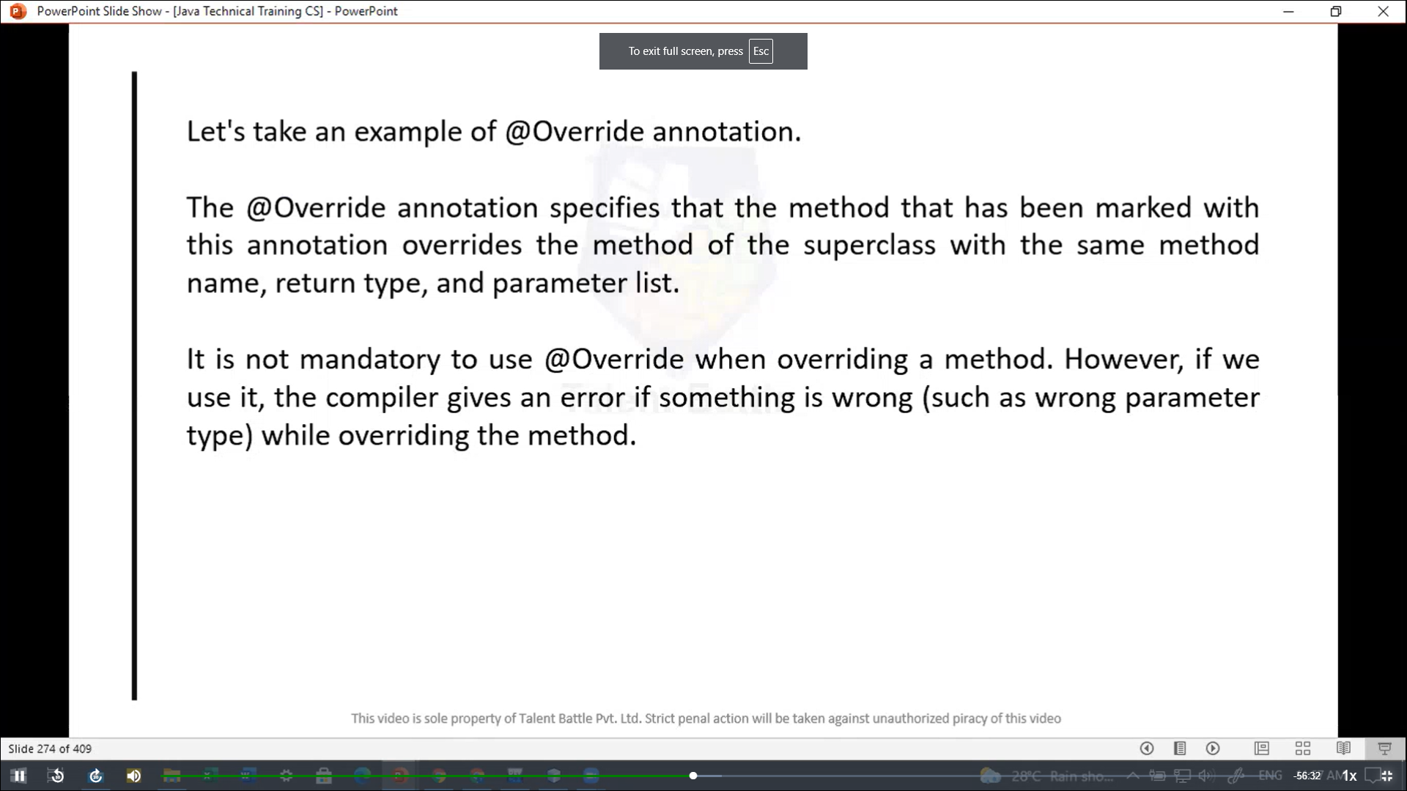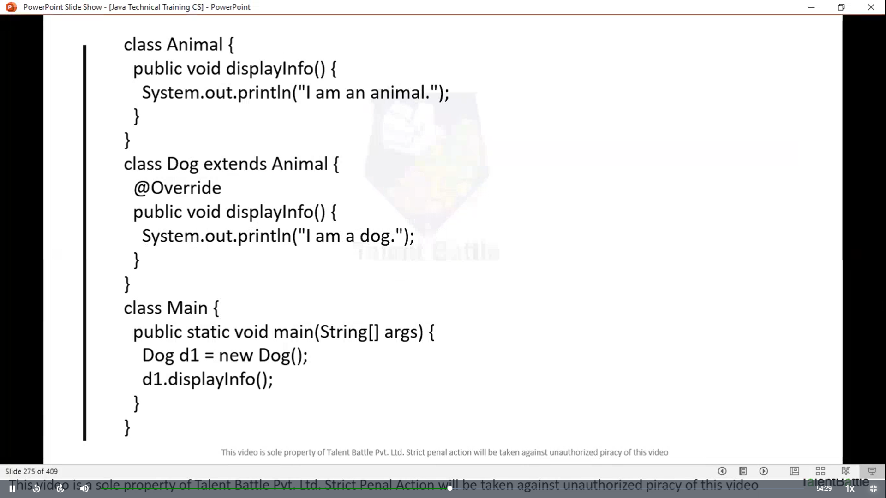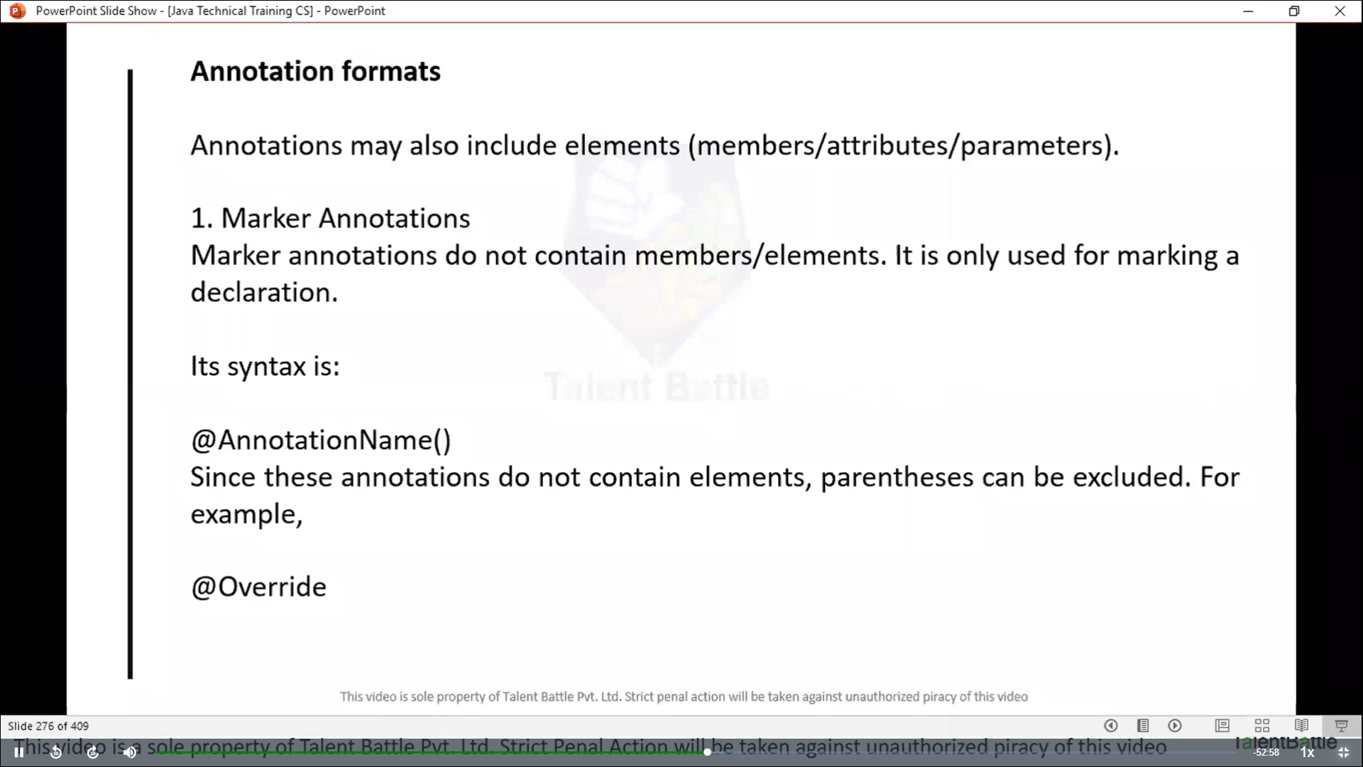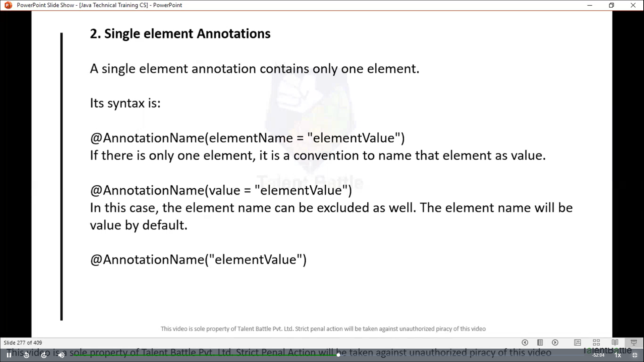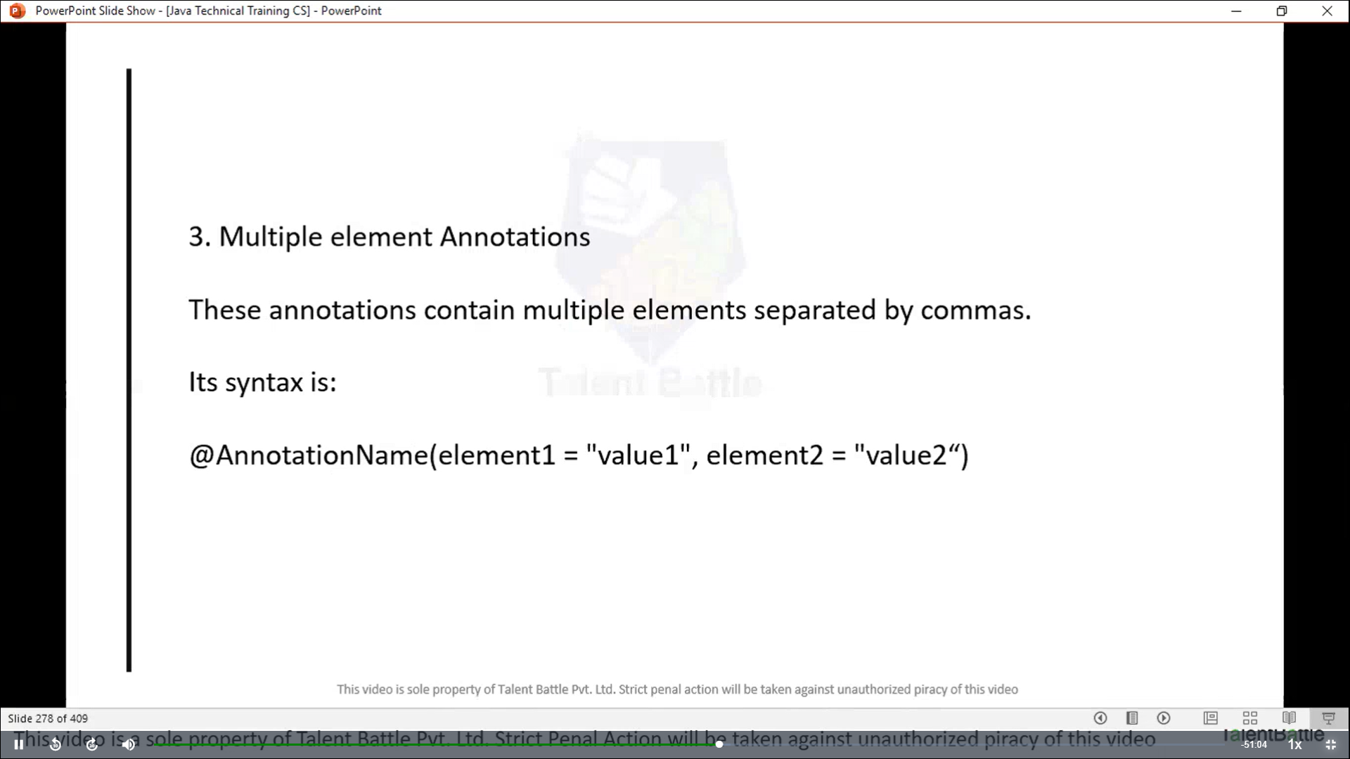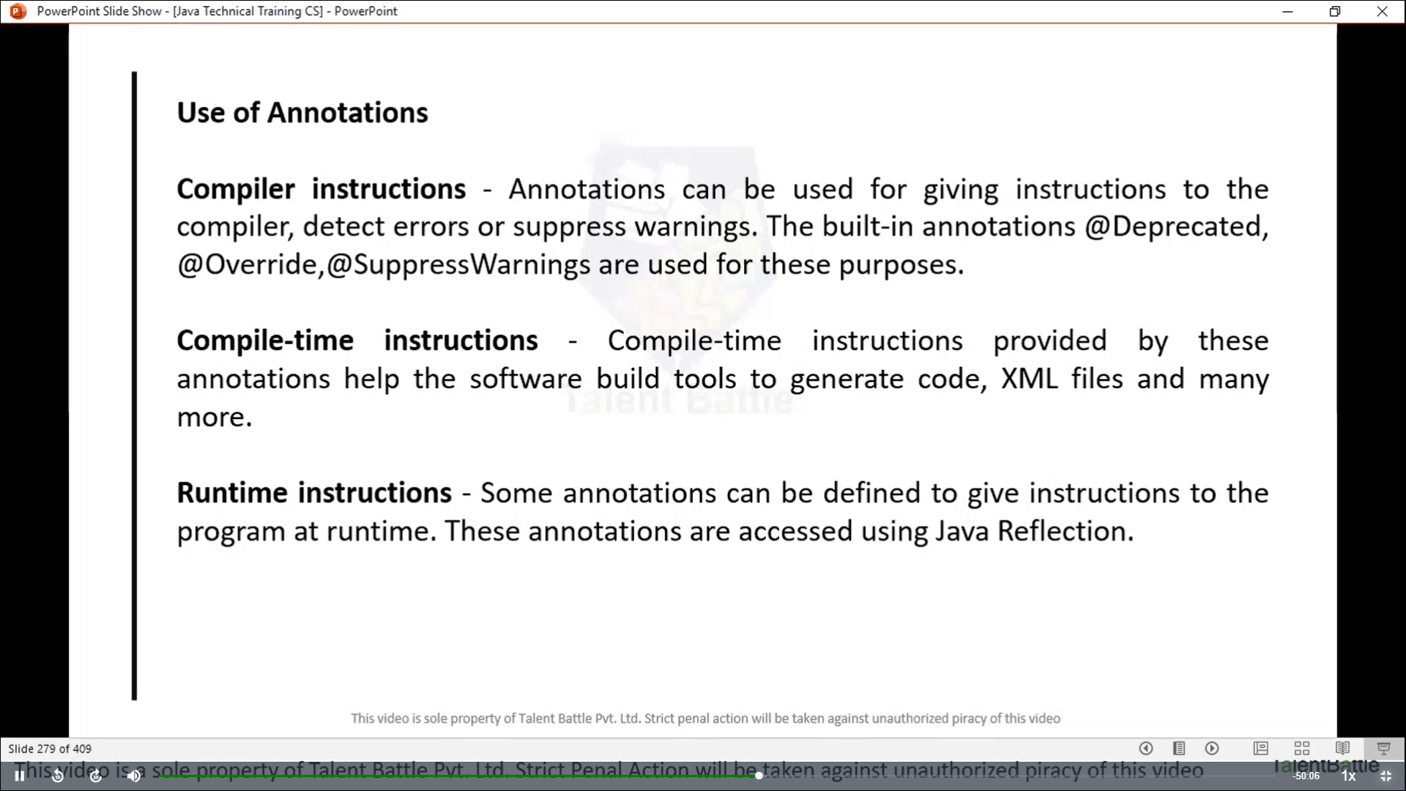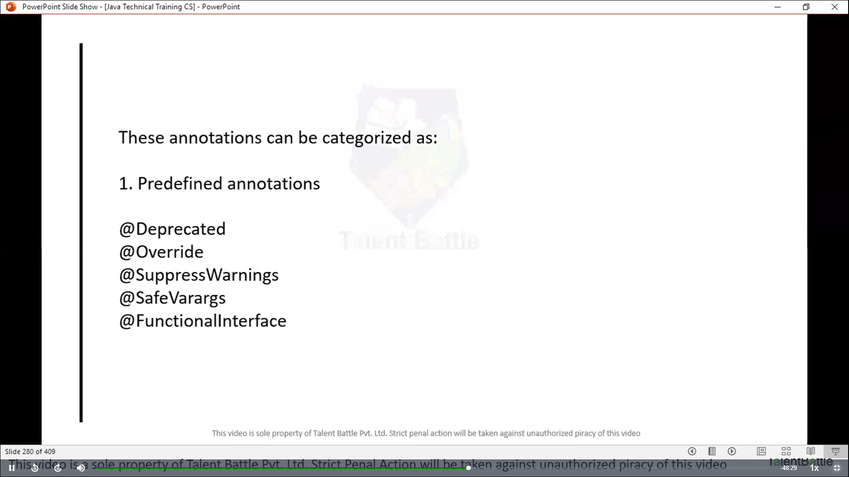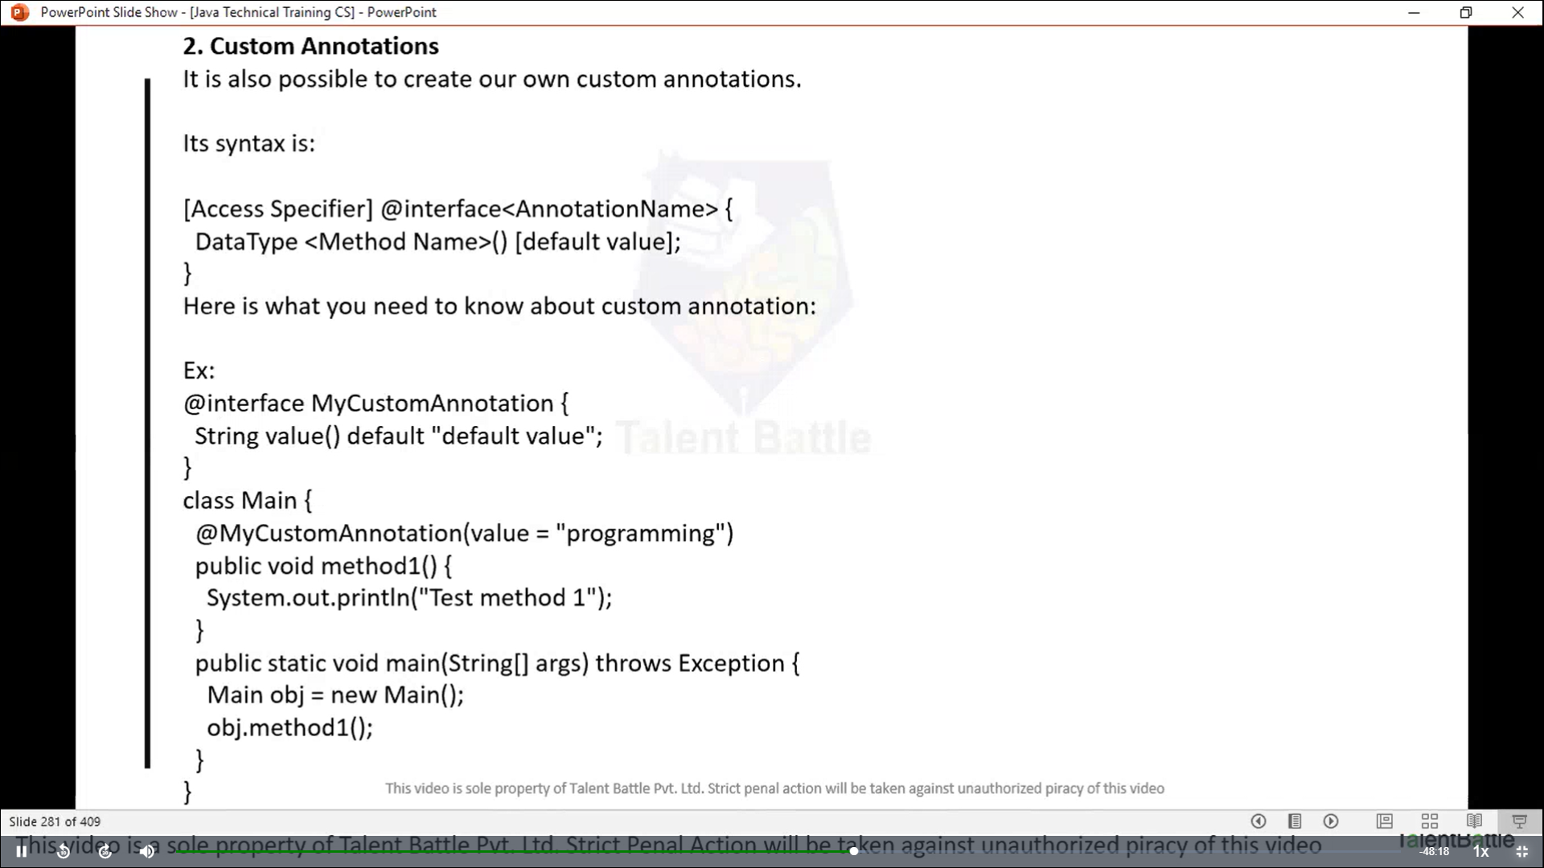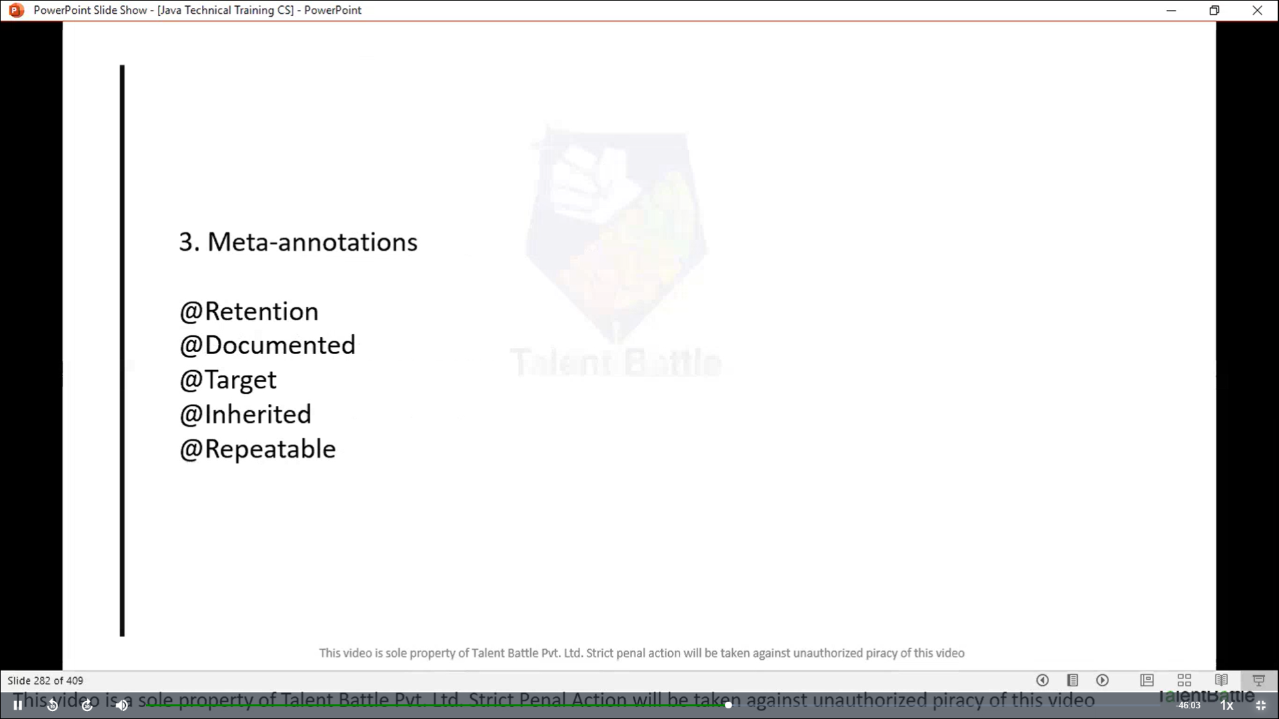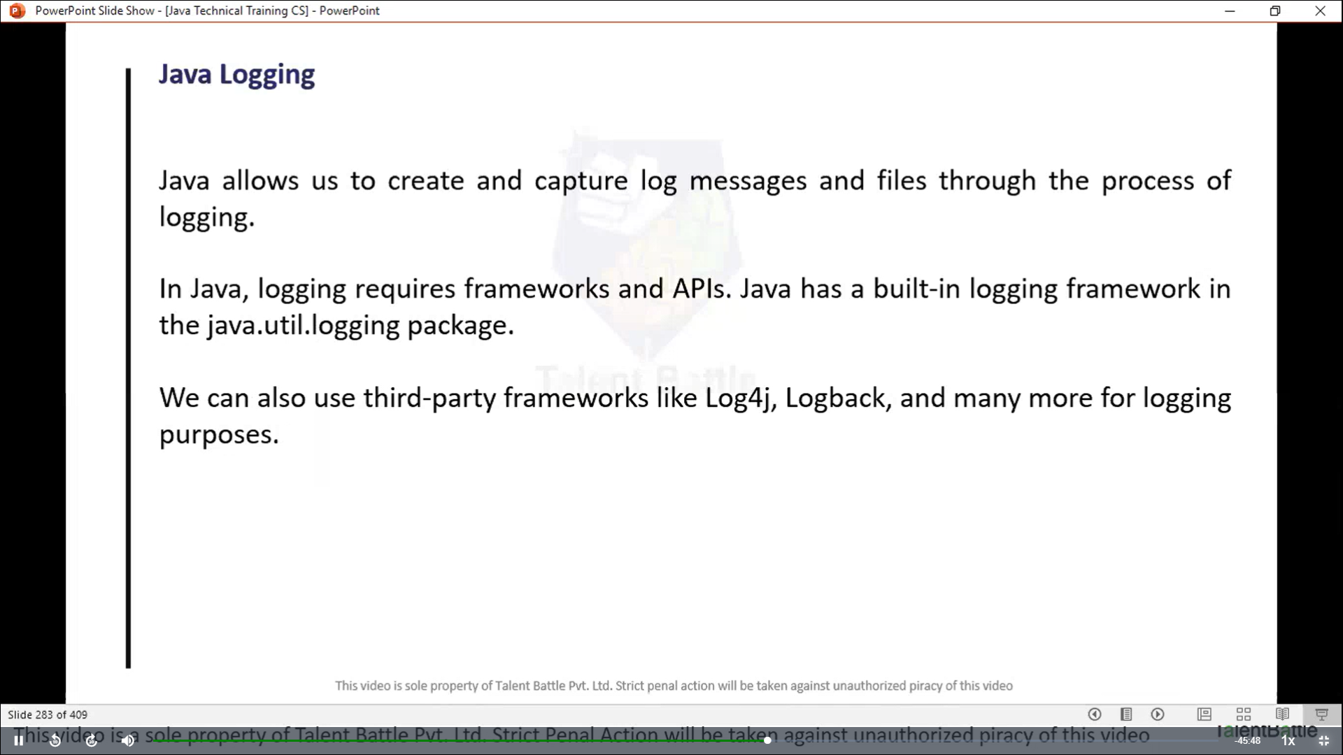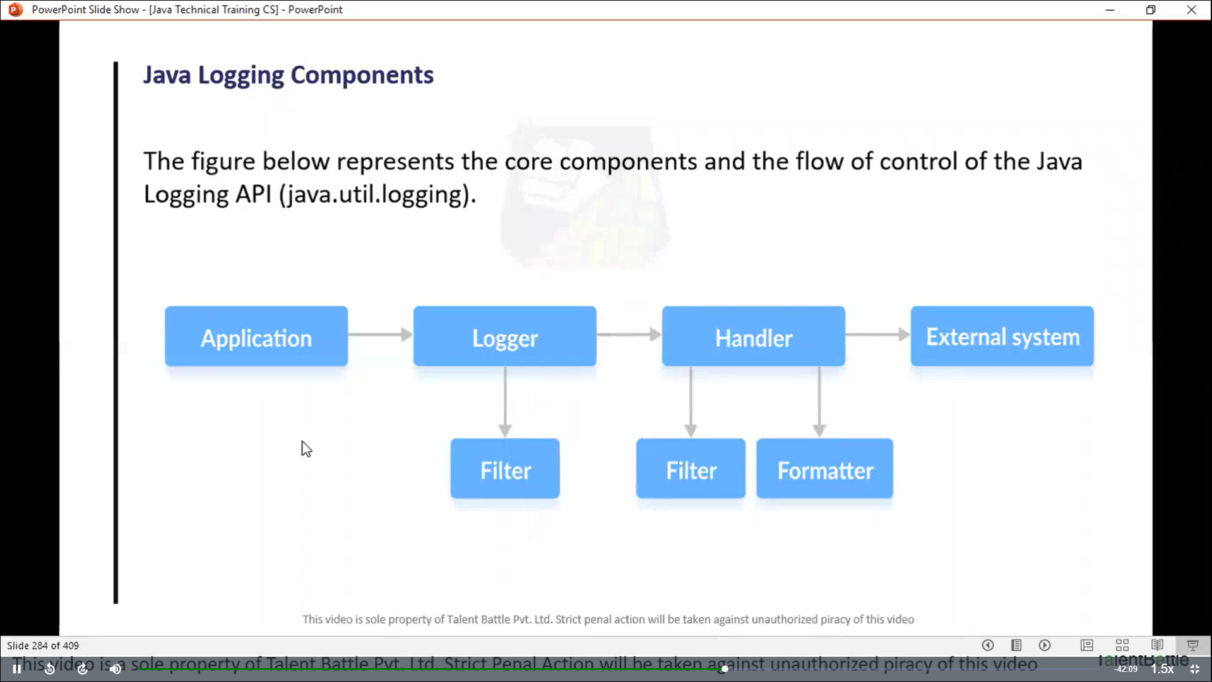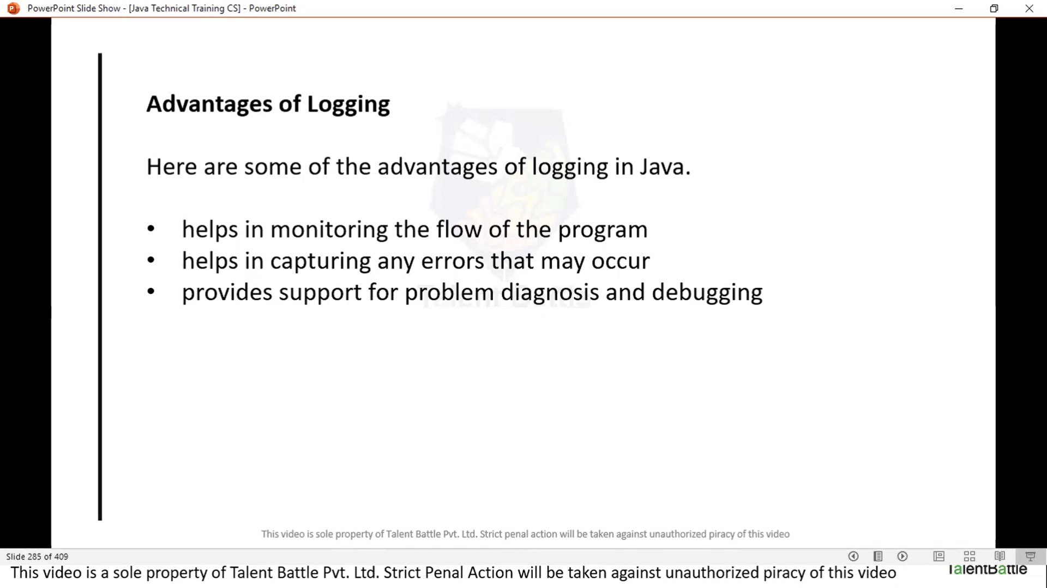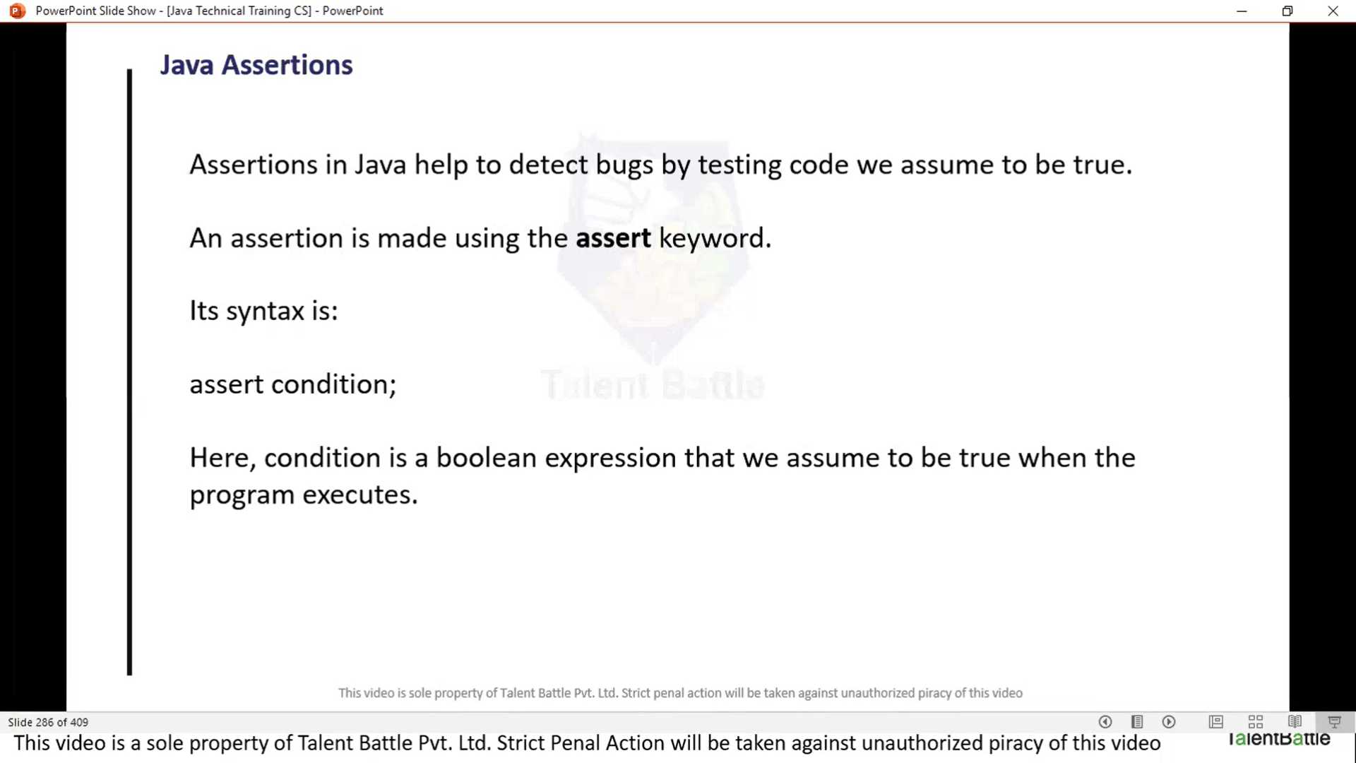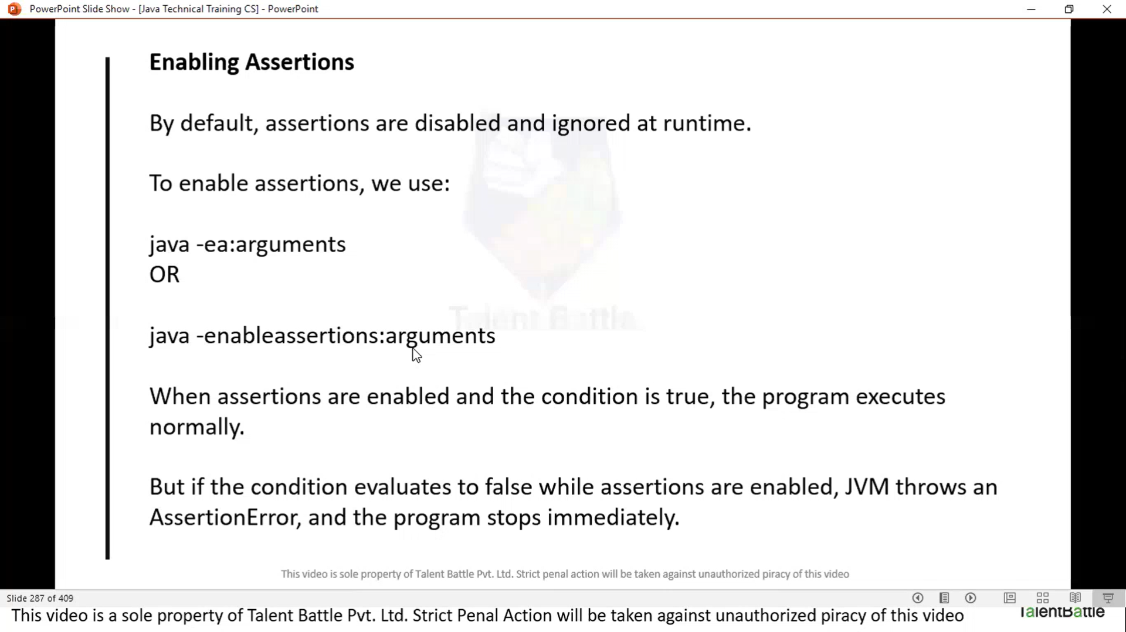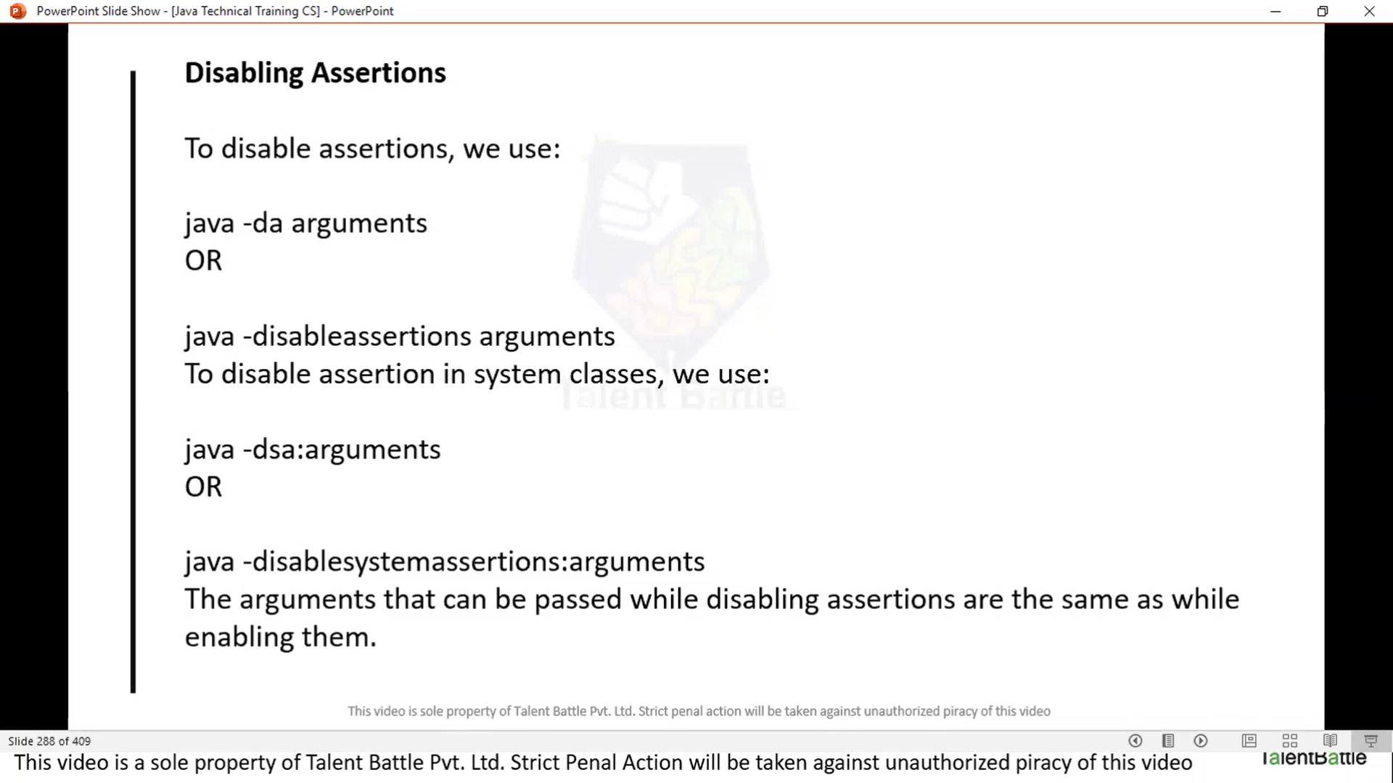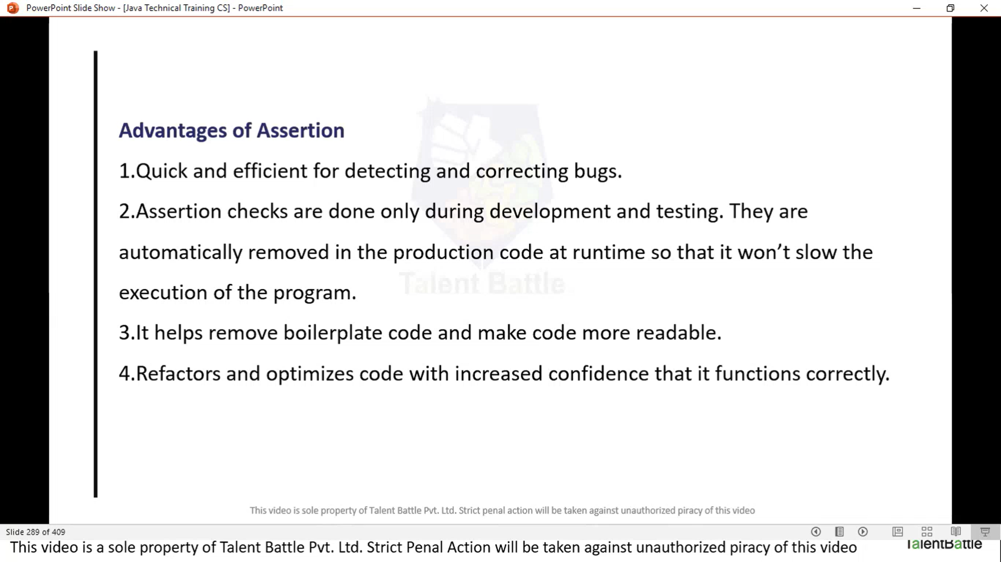

*// Java Exception Handling*

*// --------------------------------------------------*

*// Java try...catch block*

*/\**

*class Main {*

*public static void main(String[] args){*

*try {*

*int divideByZero = 5/0;*

*System.out.println("Rest of code in try block...");*

*} catch (ArithmeticException e) {*

*// TODO: handle exception*

*System.out.println("ArithmeticException => " + e.getMessage());*

*}*

*}*

*}*

*\*/*

*// ++++++++++++++++ output +++++++++++++++++++*

*// @Dheeraj2002kumar ➜ /workspaces/Foundation-Language/Java (main) $ javac Day9/Main.java*

*// @Dheeraj2002kumar ➜ /workspaces/Foundation-Language/Java (main) $ java Day9/Main.java*

*// ArithmeticException => / by zero*

*// ---------------------------------------------*

*// Java finally block*

*/\**

*class Main{*

*public static void main(String[] args){*

*try {*

*// code that generates exception*

*int divideByZero = 5/0;*

*} catch (ArithmeticException e) {*

*// TODO: handle exception*

*System.out.println("ArithmeticException => " + e.getMessage());*

*}*

*finally {*

*System.out.println("This is the finally block...");*

*}*

*}*

*}*

*\*/*

*// +++++++++++++++++++++ output +++++++++++++++++++++++++*

*// @Dheeraj2002kumar ➜ /workspaces/Foundation-Language/Java (main) $ javac Day9/Main.java*

*// @Dheeraj2002kumar ➜ /workspaces/Foundation-Language/Java (main) $ java Day9/Main.java*

*// ArithmeticException => / by zero*

*// This is the finally block...*

*// -------------------------------------------------------*

*// Java throw and throws keyword*

*/\**

*class Main{*

*public static void divideByZero(){*

*// throw an exception*

*throw new ArithmeticException("Trying to divide by 0");*

*}*

*public static void main(String[] args) {*

*divideByZero();*

*}*

*}*

*\*/*

*// ++++++++++++++++ output ++++++++++++++++++++++++*

*// @Dheeraj2002kumar ➜ /workspaces/Foundation-Language/Java (main) $ javac Day9/Main.java*

*// @Dheeraj2002kumar ➜ /workspaces/Foundation-Language/Java (main) $ java Day9/Main.java*

*// Exception in thread "main" java.lang.ArithmeticException: Trying to divide by 0*

*//         at Main.divideByZero(Main.java:72)*

*//         at Main.main(Main.java:76)*

*// ----------------------------------------------*

*// Multiple Catch blocks*

*/\**

*class ListOfNumbers {*

*public int[] arr = new int[10];*

*public void writeList(){*

*try {*

*arr[10] = 11;*

*} catch (NumberFormatException e) {*

*// TODO: handle exception*

*System.out.println("NumberFormatException => " + e.getMessage());*

*} catch (IndexOutOfBoundsException e){*

*System.out.println("IndexOutOfBoundsException => " + e.getMessage());*

*}*

*}*

*}*

*class Main{*

*public static void main(String[] args){*

*ListOfNumbers list = new ListOfNumbers();*

*list.writeList();*

*}*

*}*

*\*/*

*// ++++++++++++++++ output ++++++++++++++++++++++++*

*// @Dheeraj2002kumar ➜ /workspaces/Foundation-Language/Java/Day9 (main) $ javac Main.java*

*// @Dheeraj2002kumar ➜ /workspaces/Foundation-Language/Java/Day9 (main) $ java Main*

*// IndexOutOfBoundsException => Index 10 out of bounds for length 10*

*//-----------------------------------------------------*

*// What is the output of the following code snippet?*

*/\**

*public class Main {*

*public void checkForExceptions(int num1, int num2){*

*int intArr[] = {1,2,3};*

*String str = null;*

*System.out.println("Befor any exception!");*

*try {*

*str.charAt(0);*

*System.out.println(num1 / num1);*

*System.out.println("Enjoy no exception!");*

*}*

*catch (ArithmeticException e) {*

*// TODO: handle exception*

*System.out.println("ArithmeticException Handler!");*

*}*

*catch (NullPointerException e){*

*System.out.println("NullPointerException handler!");*

*}*

*catch (Exception e){*

*System.out.println("Default exception handler!");*

*}*

*finally{*

*System.out.println("In finally!");*

*}*

*System.out.println("After handling exception!");*

*}*

*public static void main(String[] args) {*

*Main exceptionMain = new Main();*

*try {*

*exceptionMain.checkForExceptions(2, 0);*

*}*

*catch (ArithmeticException e) {*

*// TODO: handle exception*

*System.out.println("ArithmeticException handler in main!");*

*}*

*System.out.println("End of main...");*

*}*

*}*

*\*/*

*// +++++++++++++++++++++ output ++++++++++++++++++++++++++*

*// @Dheeraj2002kumar ➜ /workspaces/Foundation-Language/Java/Day9 (main) $ javac Main.java*

*// @Dheeraj2002kumar ➜ /workspaces/Foundation-Language/Java/Day9 (main) $ java Main*

*// Befor any exception!*

*// NullPointerException handler!*

*// In finally!*

*// After handling exception!*

*// End of main...*

*//---------------------------------------------------------*

*// Annotation*

*/\**

*class Animal {*

*public void displayInfo(){*

*System.out.println("I am an animal...");*

*}*

*}*

*class Dog extends Animal {*

*@Override // Annotation*

*public void displayInfo(){*

*System.out.println("I am a dog...");*

*}*

*}*

*public class Main {*

*public static void main(String[] args) {*

*Dog d1 = new Dog();*

*d1.displayInfo();*

*}*

*}*

*\*/*

*// +++++++++++++++++++++ output ++++++++++++++++++*

*// @Dheeraj2002kumar ➜ /workspaces/Foundation-Language/Java/Day9 (main) $ javac Main.java*

*// @Dheeraj2002kumar ➜ /workspaces/Foundation-Language/Java/Day9 (main) $ java Main*

*// I am a dog...*

*// ------------------------------------------------------------------*

*// Custom Annotations*

@**interface** **MyCustomAnnotation**{

    String value() default "default value";

}

**public** **class** Main {

    @**MyCustomAnnotation**(value = "programming")

**public** **void** method1(){

            System.out.println("Test method 1");

        }

**public** **static** **void** main(String[] args) **throws** Exception {

        Main obj = new Main();

        obj.method1();

    }

}

*// ++++++++++++++++++++++ output +++++++++++++++++++++*

*// @Dheeraj2002kumar ➜ /workspaces/Foundation-Language/Java/Day9 (main) $ javac Main.java*

*// @Dheeraj2002kumar ➜ /workspaces/Foundation-Language/Java/Day9 (main) $ java Main*

*// Test method 1*

**Java List**

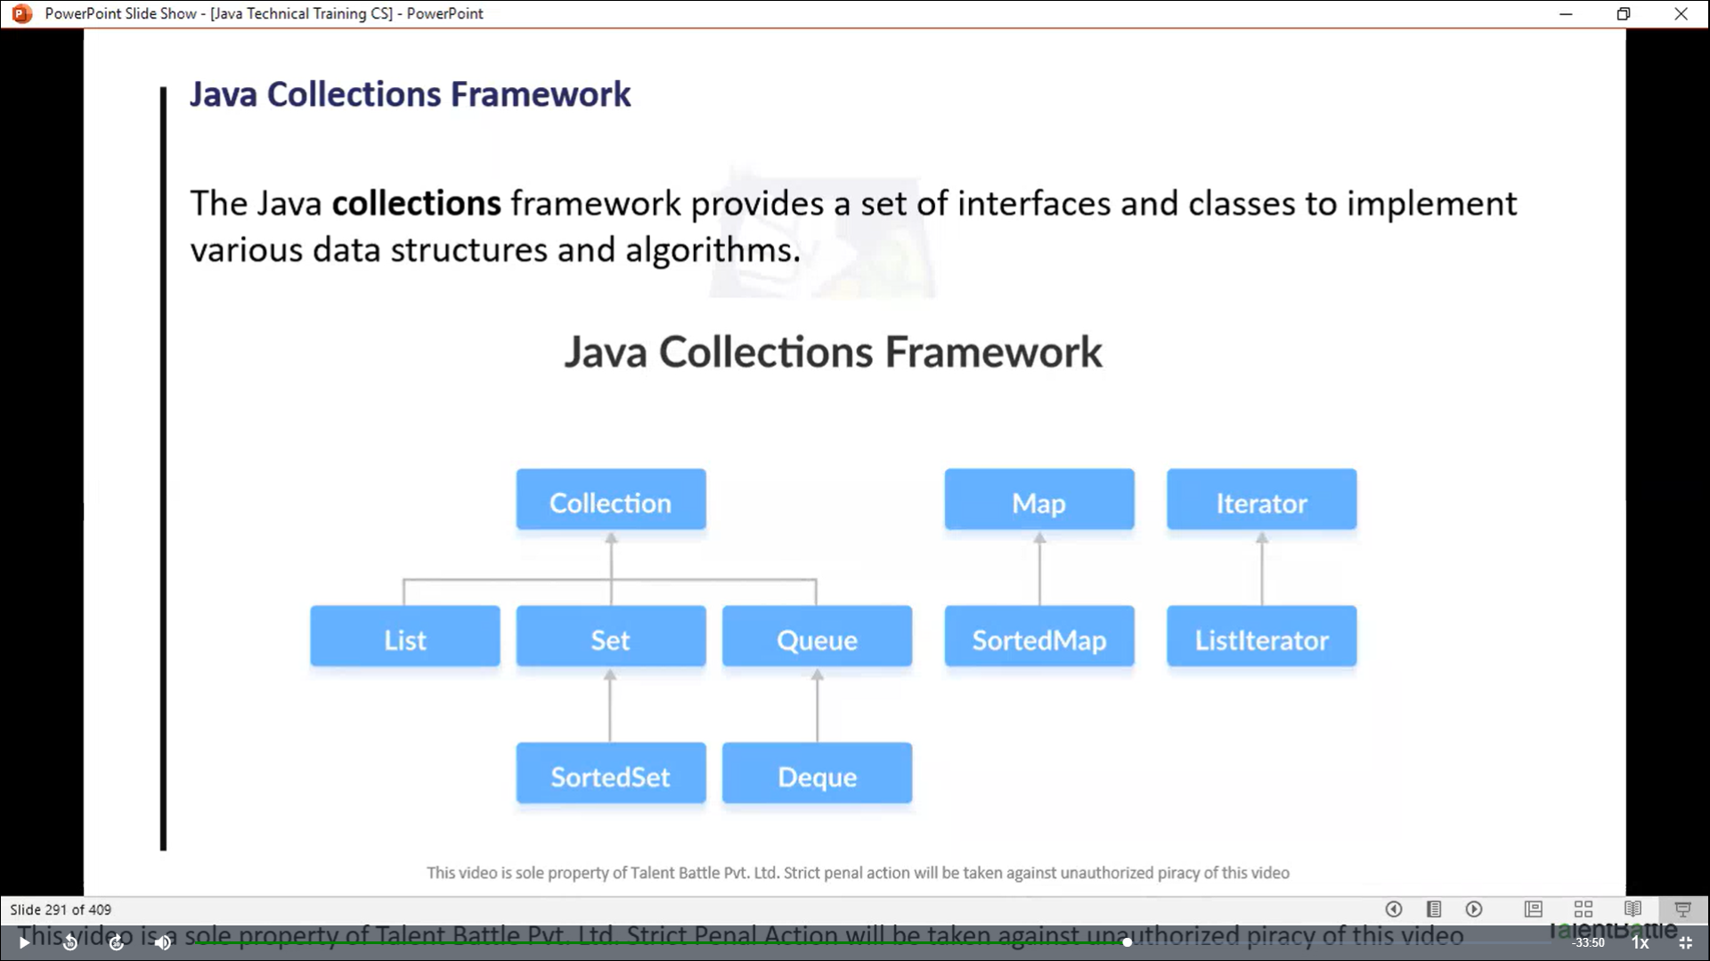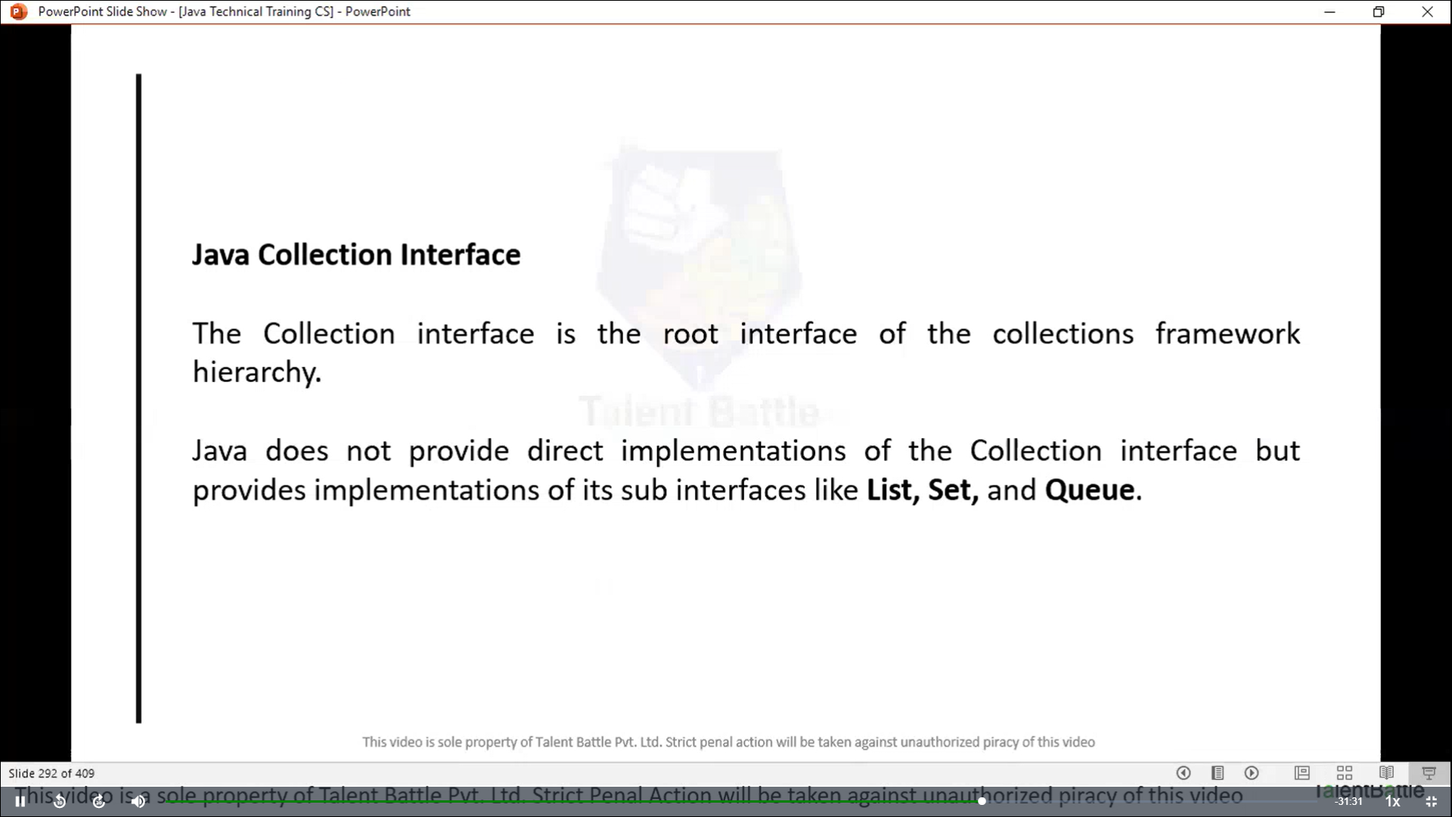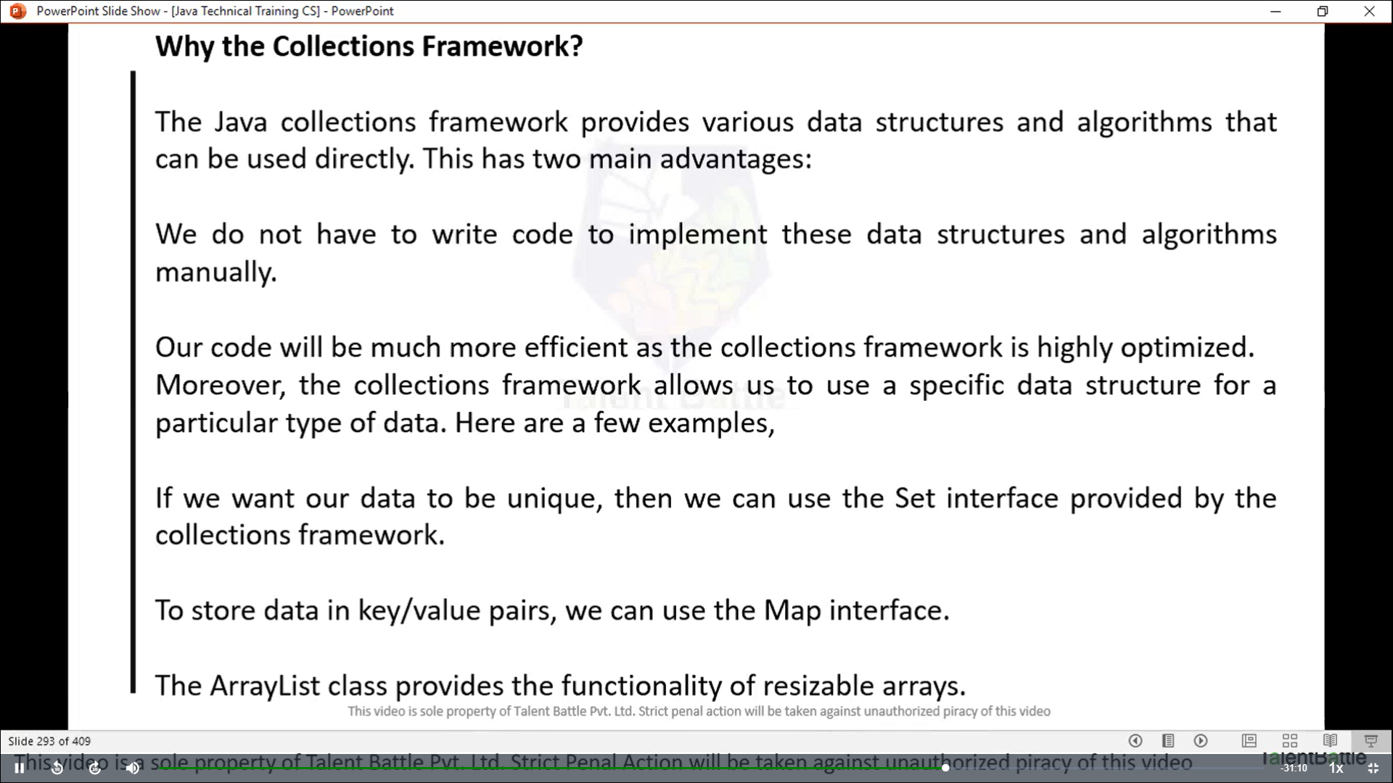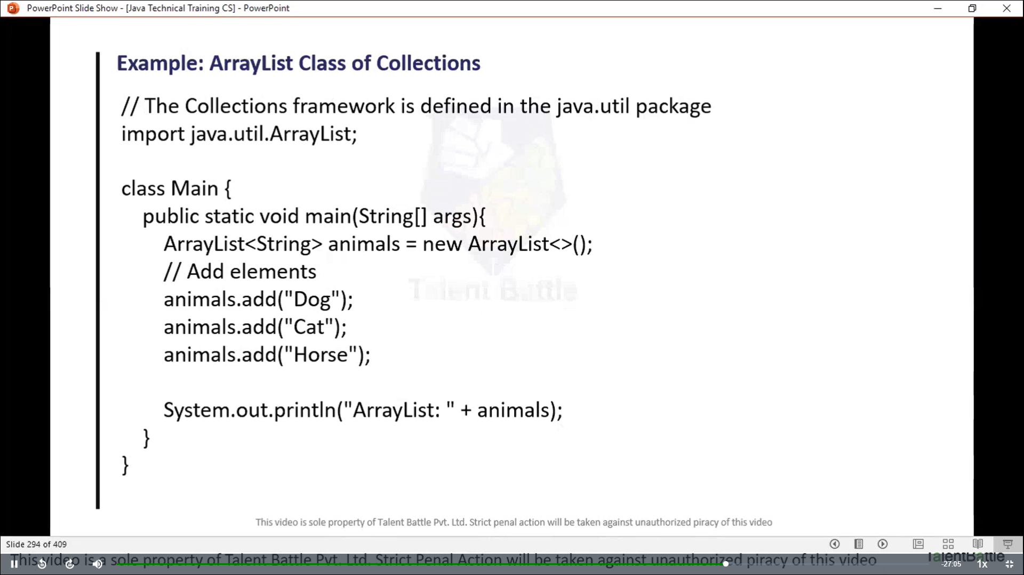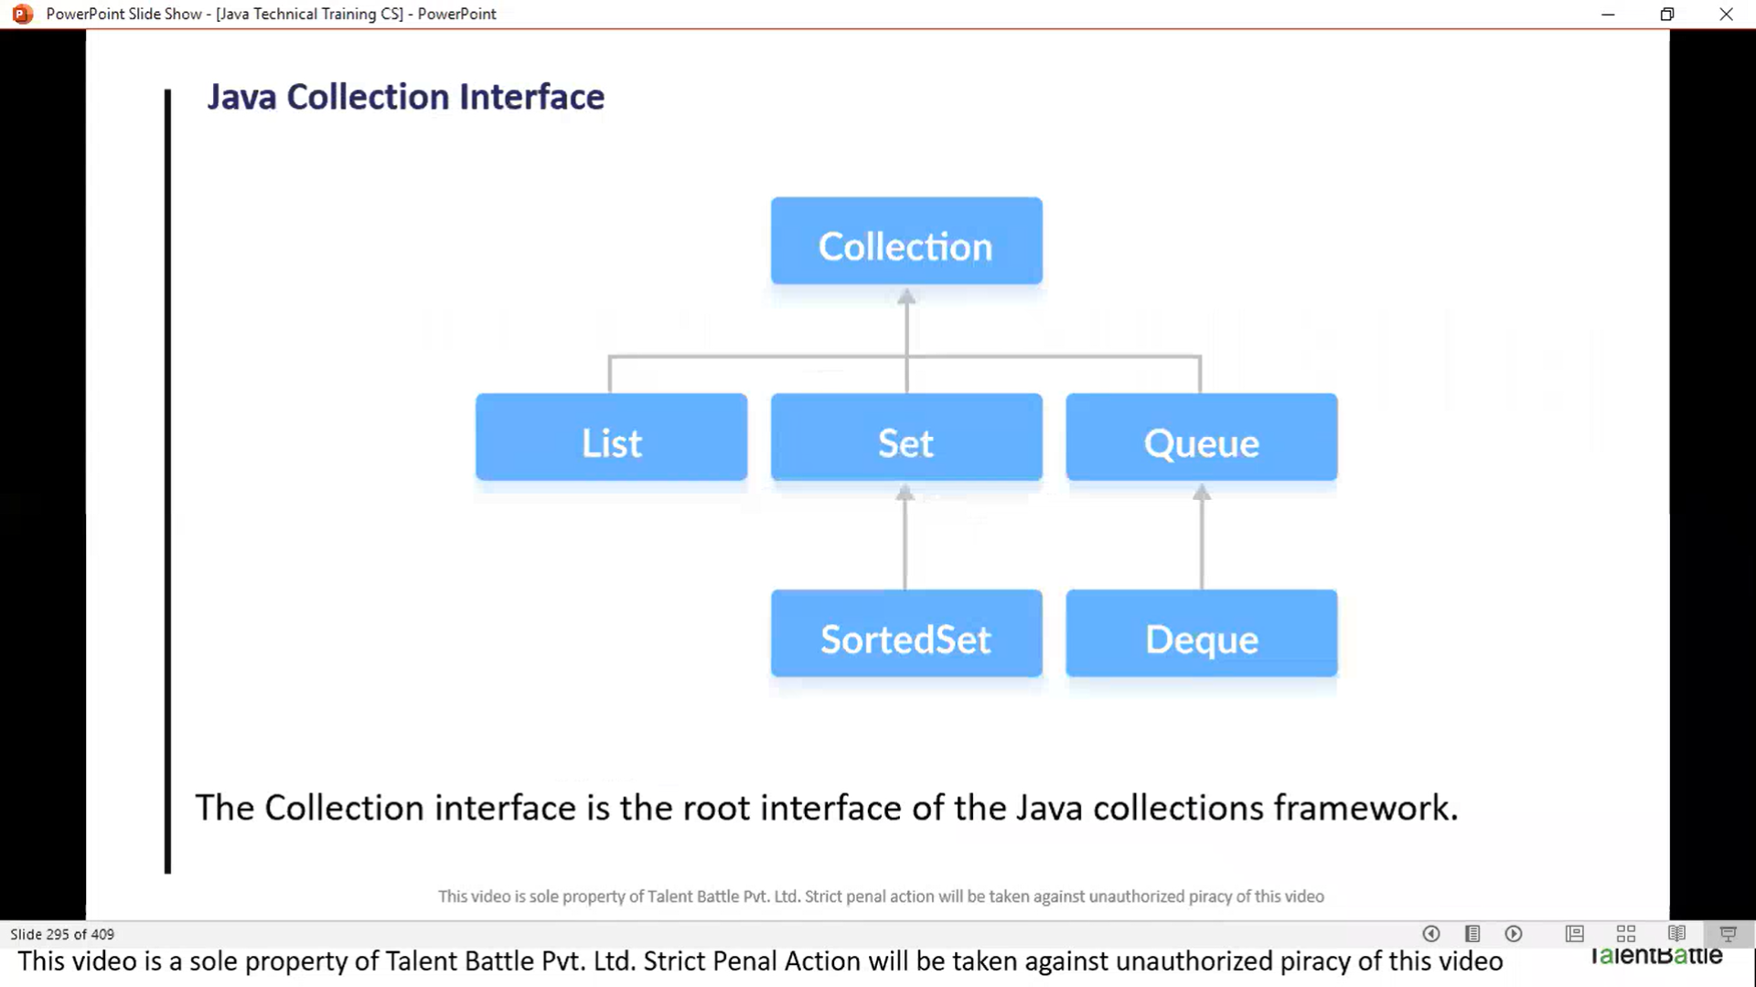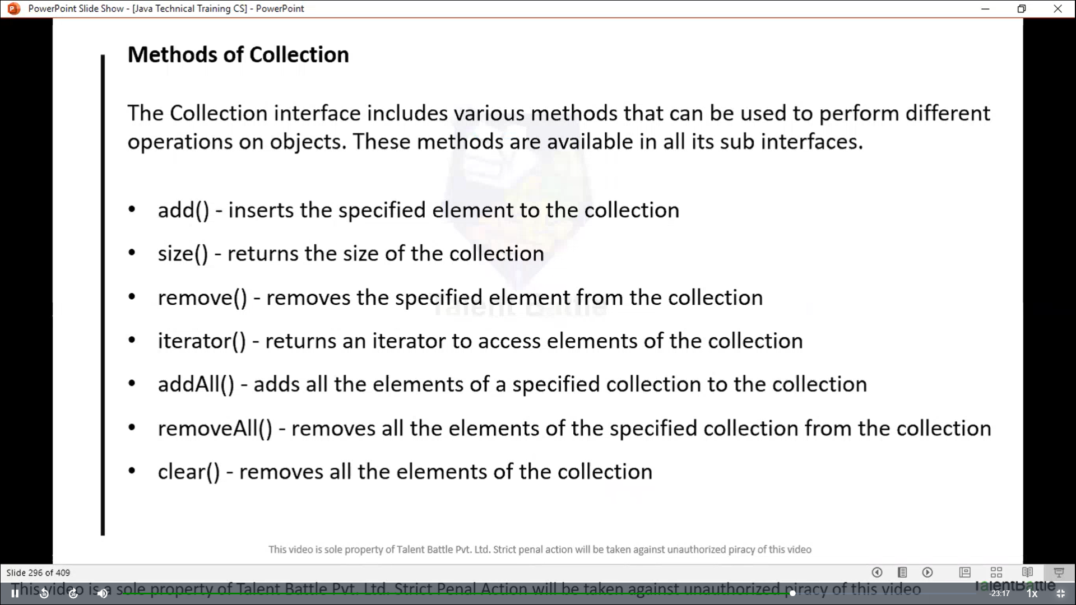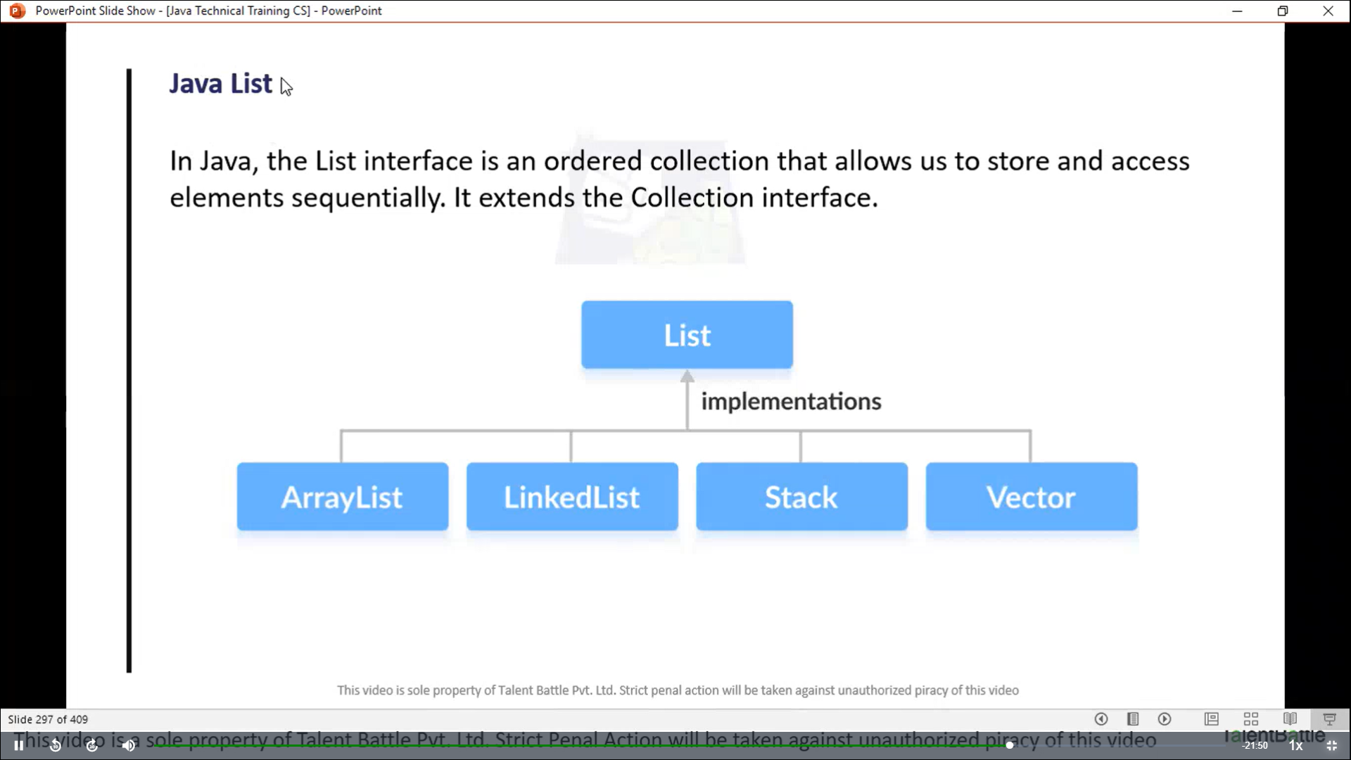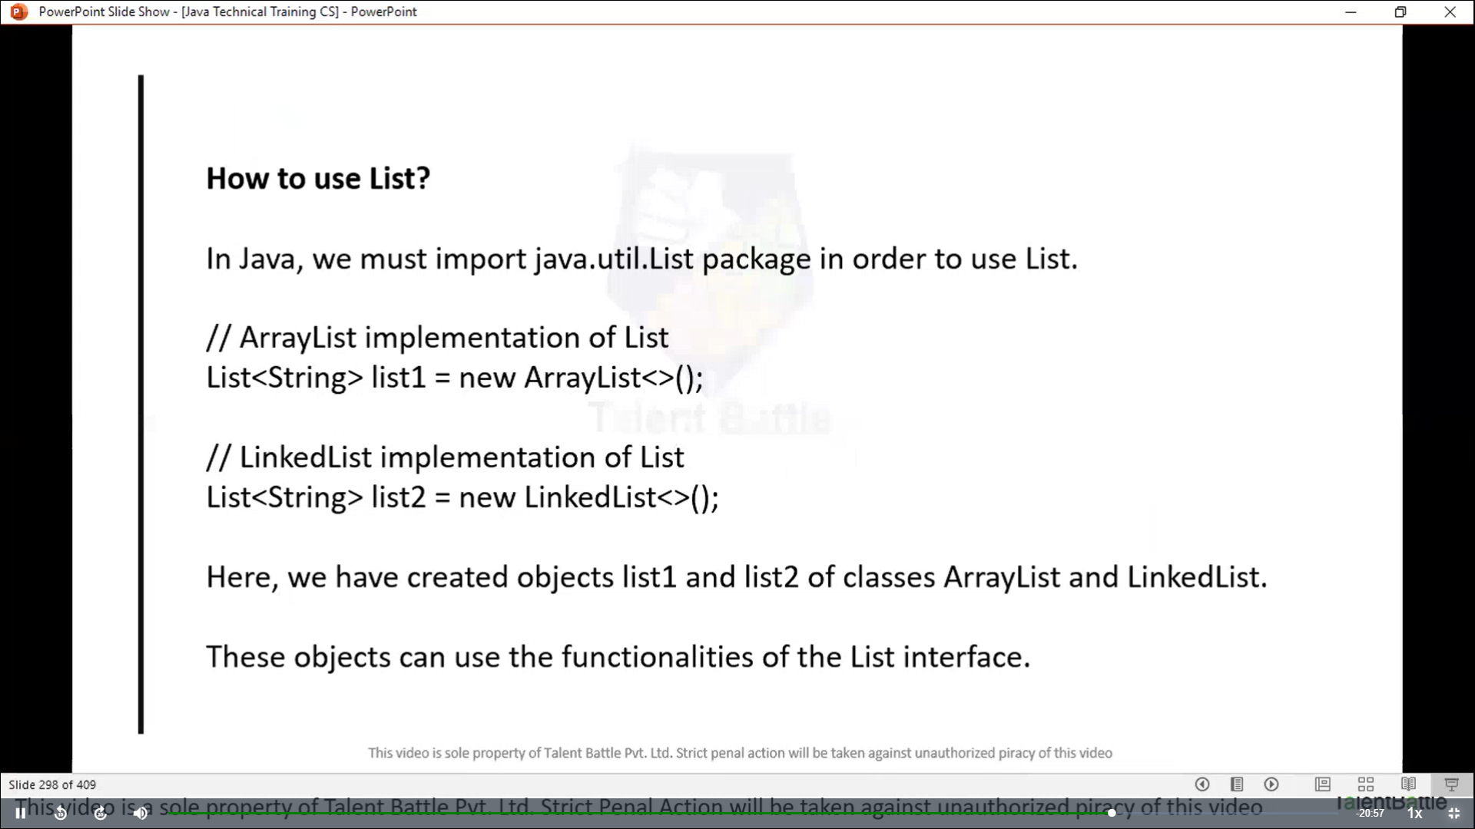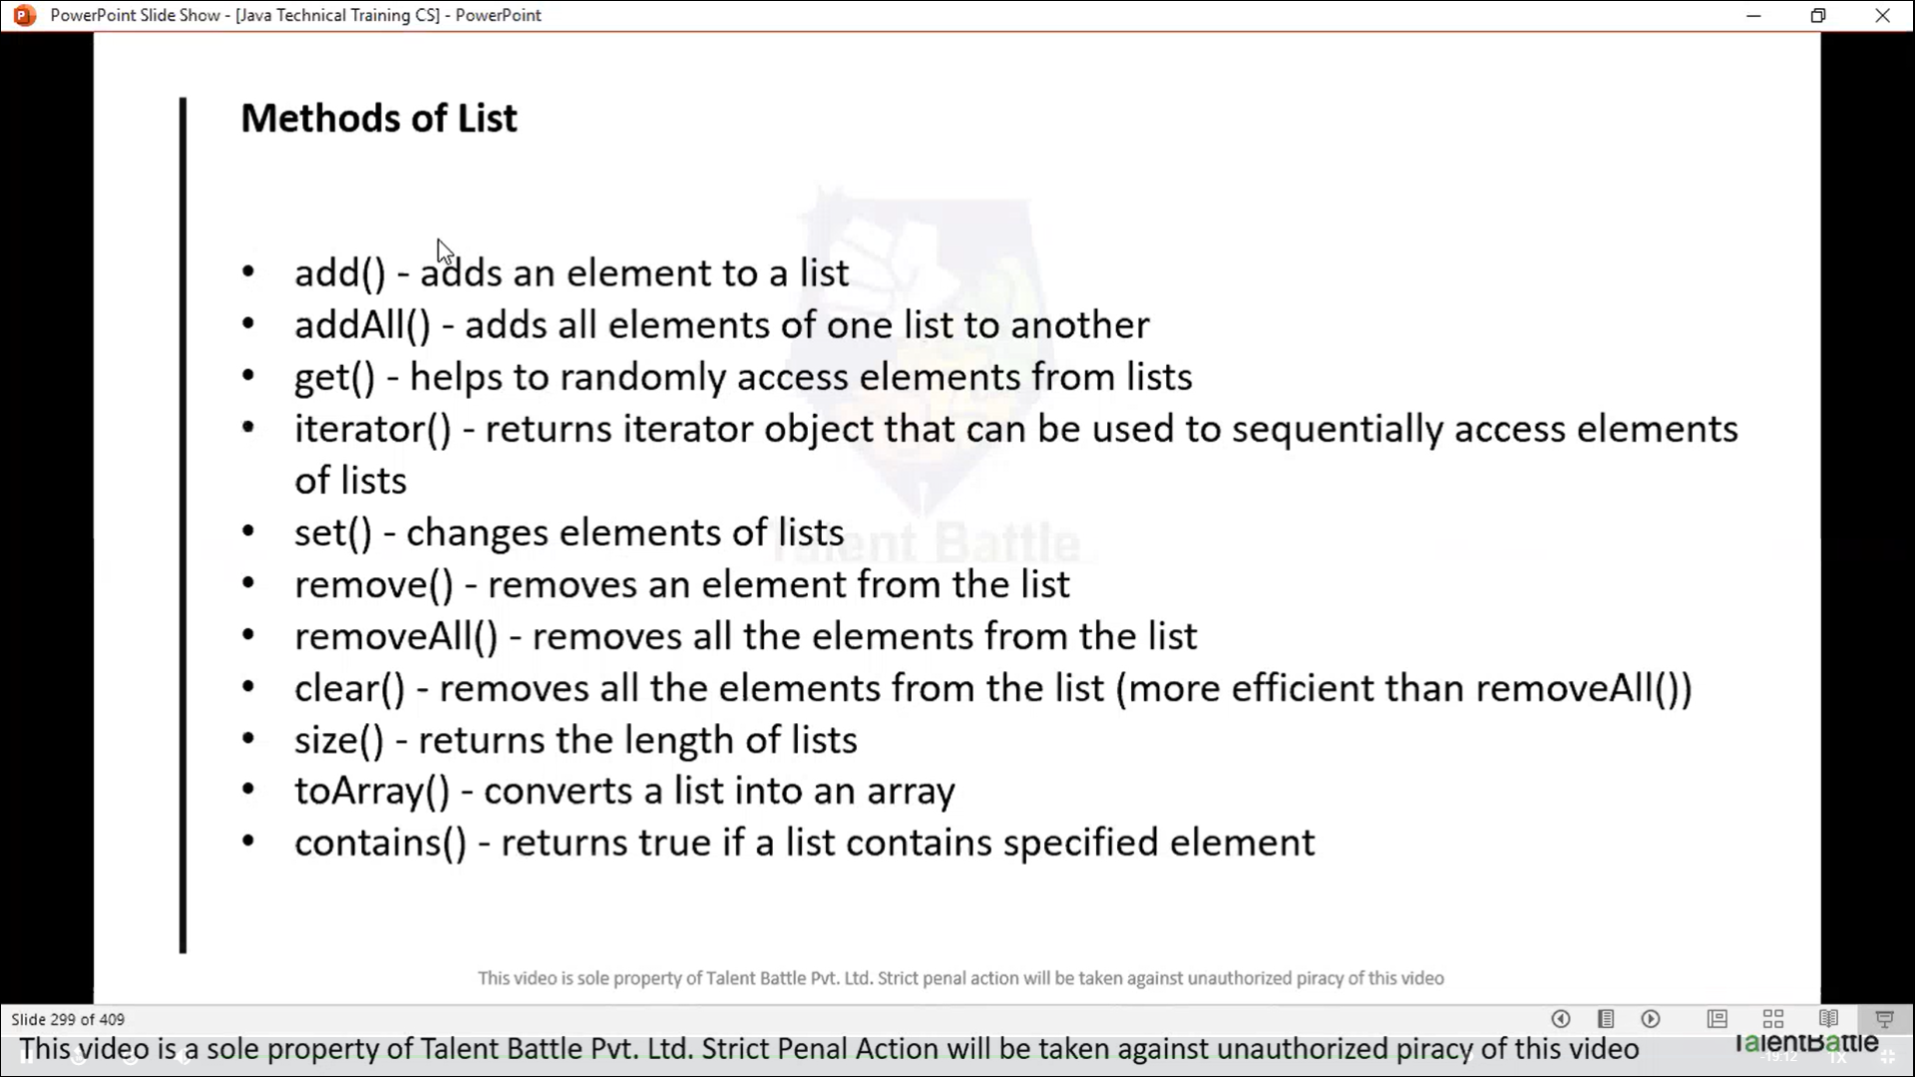

**Array list**

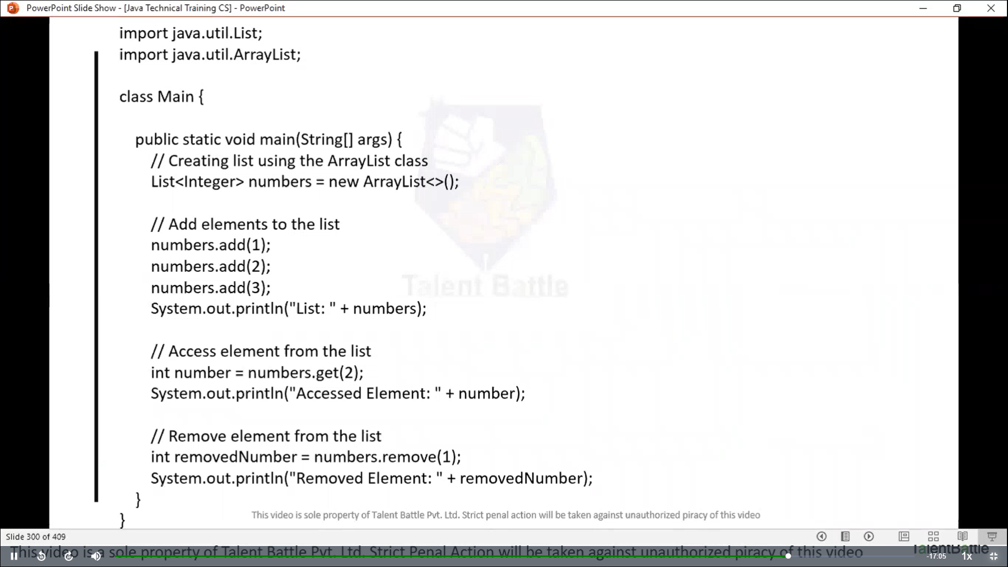

**Linked list**

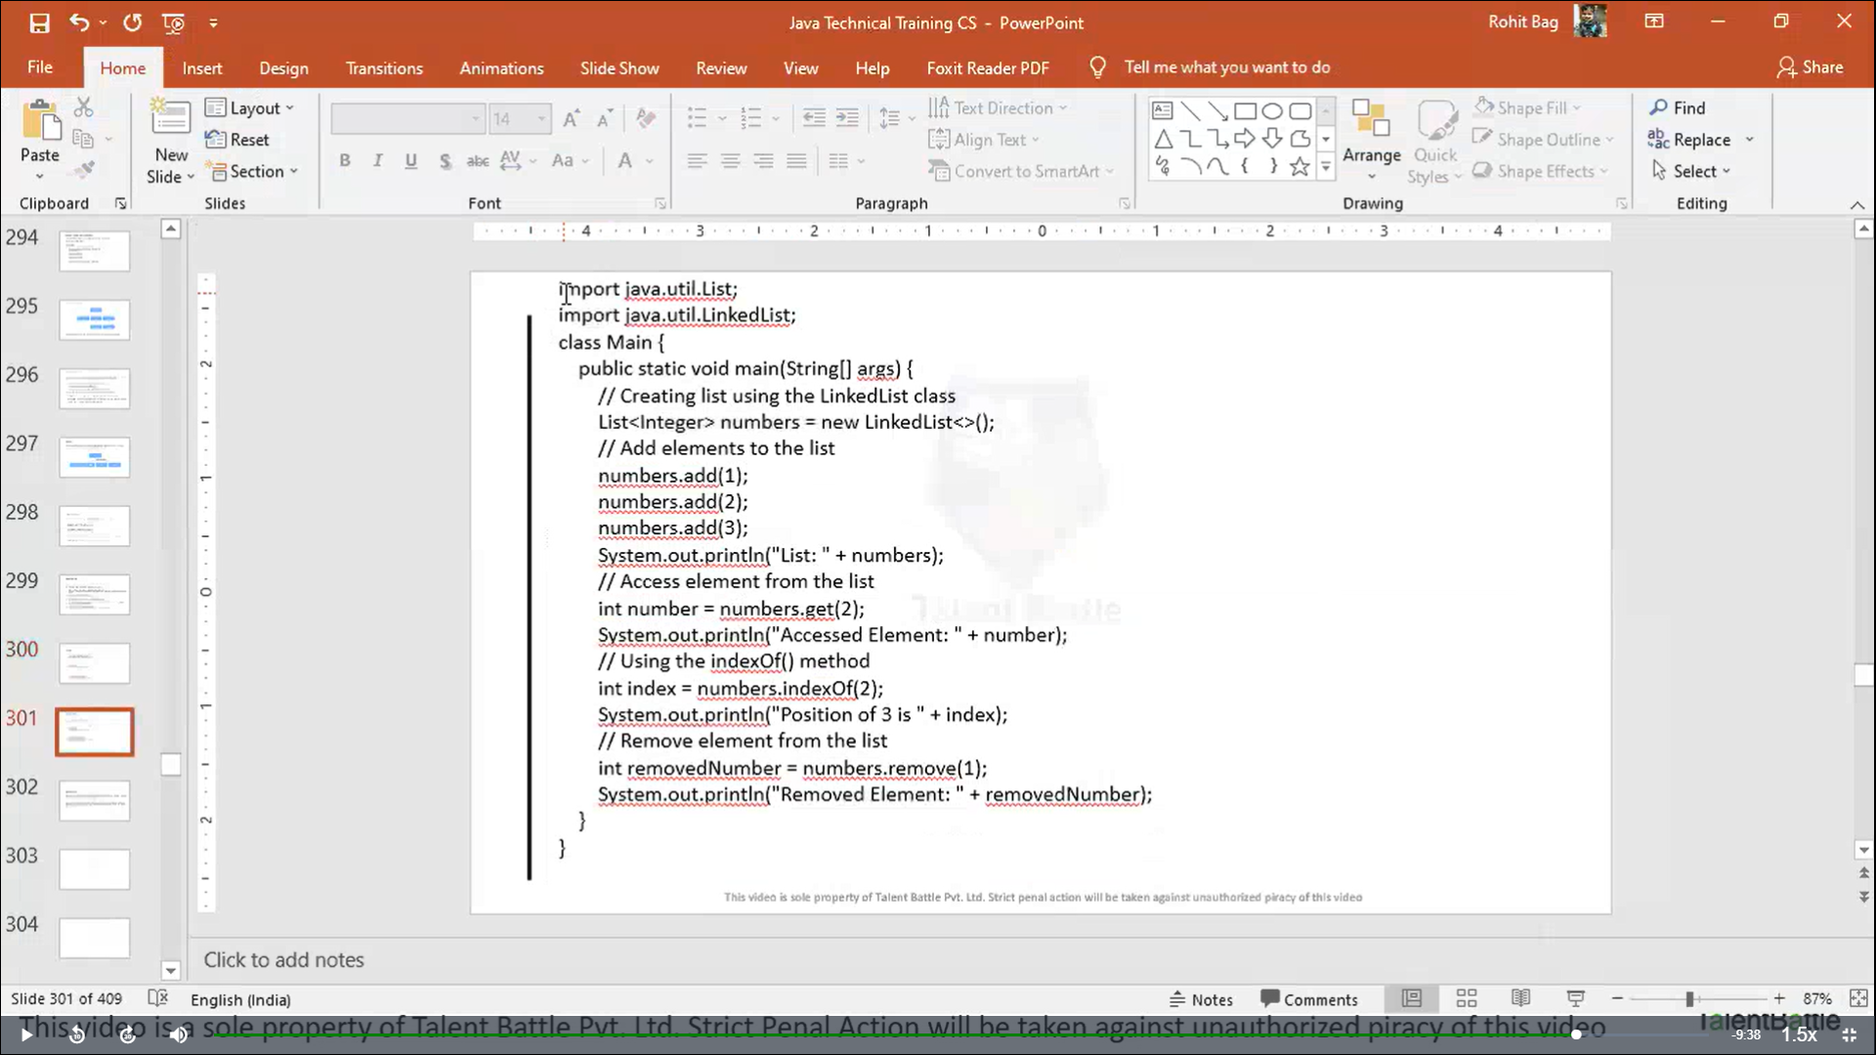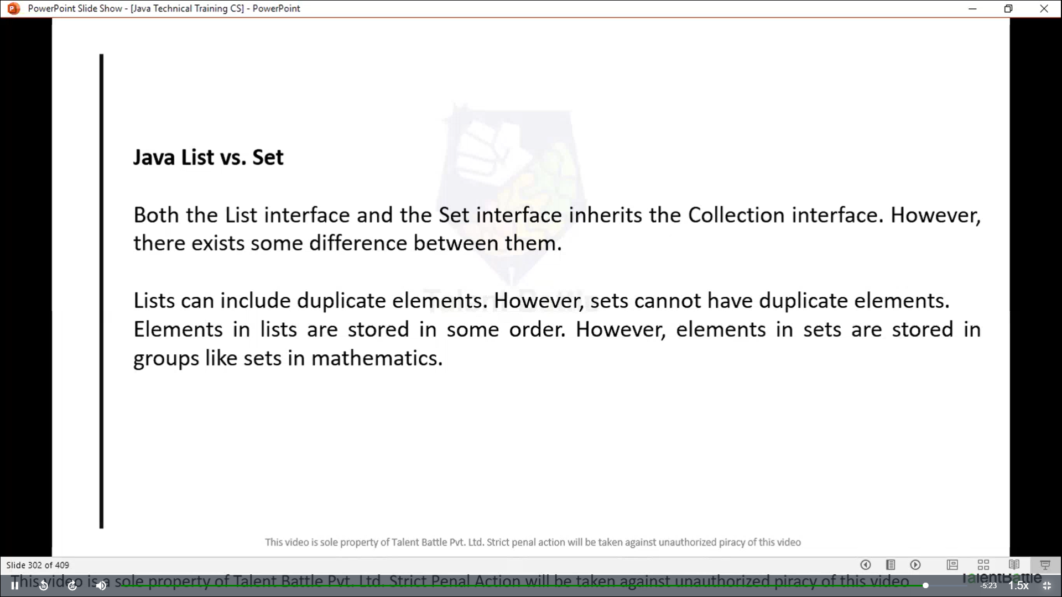

package Java_Collection_Framework;

*// ArrayList class of collections*

*// The collection framework is defined in the java.util package*

*/\**

*import java.util.ArrayList;*

*public class Main {*

*public static void main(String[] args) {*

*ArrayList<String> animals = new ArrayList<>();*

*// add elements*

*animals.add("Dog");*

*animals.add("Cat");*

*animals.add("Horse");*

*System.out.println("ArrayList: " + animals);*

*}*

*}*

*\*/*

*// +++++++++++++++++++++++ output ++++++++++++++++++++++++*

*// @Dheeraj2002kumar ➜ .../Foundation-Language/Java/Day9/Java_Collection_Framework (main) $ javac Main.java*

*// @Dheeraj2002kumar ➜ .../Foundation-Language/Java/Day9/Java_Collection_Framework (main) $ java Main.java*

*// ArrayList: [Dog, Cat, Horse]*

*// ---------------------------------------------------*

*// java list (ArrayList)*

*/\**

*import java.util.List;*

*import java.util.ArrayList;*

*public class Main {*

*public static void main(String[] args) {*

*// Creating list using the ArrayList class*

*List<Integer> numbers = new ArrayList<>();*

*// add elements to the list*

*numbers.add(4);*

*numbers.add(9);*

*numbers.add(8);*

*System.out.println("List: "+ numbers);*

*// Access element from the list*

*int number = numbers.get(2); // 2 is index*

*System.out.println("Accessed Element: " + number);*

*// Remove element from the list*

*int removedNumber = numbers.remove(1); // 1 is index position*

*System.out.println("Removed Element: " + removedNumber);*

*}*

*}*

*\*/*

*// ++++++++++++++++++++++++++++ output ++++++++++++++++++++++++++*

*// @Dheeraj2002kumar ➜ .../Foundation-Language/Java/Day9/Java_Collection_Framework (main) $ javac Main.java*

*// @Dheeraj2002kumar ➜ .../Foundation-Language/Java/Day9/Java_Collection_Framework (main) $ java Main.java*

*// List: [4, 9, 8]*

*// Accessed Element: 8*

*// Removed Element: 9*

*// -----------------------------------------------------*

*// java list (linkedList)*

import java**.**util**.**List;

import java**.**util**.**LinkedList;

**public** **class** Main {

**public** **static** **void** main(String[] args) {

*// Creating list using the LinkedList class*

        List<Integer> numbers = new LinkedList<>();

*// add elements to the list*

        numbers.add(33);

        numbers.add(34);

        numbers.add(35);

        System.out.println("List: " + numbers);

*// Access element from the list*

**int** number = numbers.get(2); *// 2 is index position*

        System.out.println("Accessed Element: "+ number);

*// Using the indexOf() method*

**int** index1 = numbers.indexOf(2);

**int** index2 = numbers.indexOf(35);

        System.out.println("Position of 2 is: " + index1);

        System.out.println("Position of 35 is: " + index2);

*// Remove element from the list*

**int** removedNumber = numbers.remove(1);

        System.out.println("Removed Element: " + removedNumber);

        System.out.println("Fainl linkedList is: " + numbers);

    }

}

*// ++++++++++++++++++++++++ output ++++++++++++++++++++*

*// @Dheeraj2002kumar ➜ .../Foundation-Language/Java/Day9/Java_Collection_Framework (main) $ javac Main.java*

*// @Dheeraj2002kumar ➜ .../Foundation-Language/Java/Day9/Java_Collection_Framework (main) $ java Main.java*

*// List: [33, 34, 35]*

*// Accessed Element: 35*

*// Position of 2 is: -1*

*// Position of 35 is: 2*

*// Removed Element: 34*

*// Fainl linkedList is: [33, 35]*